HTML is used for structure and layout of web page and organize elements

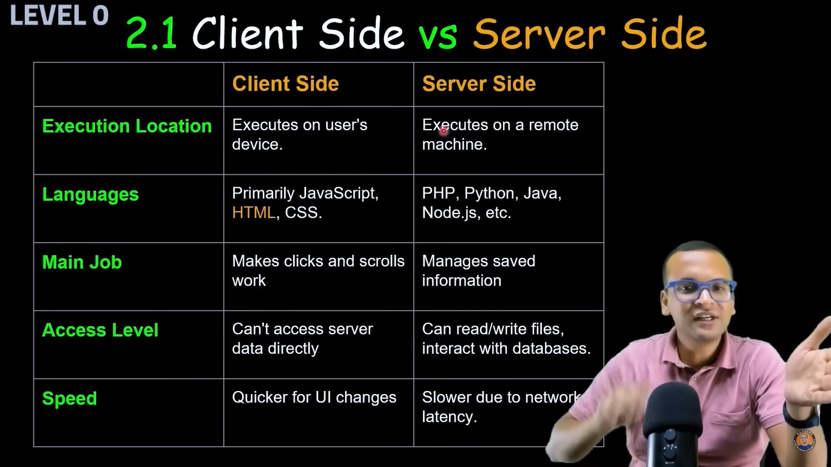

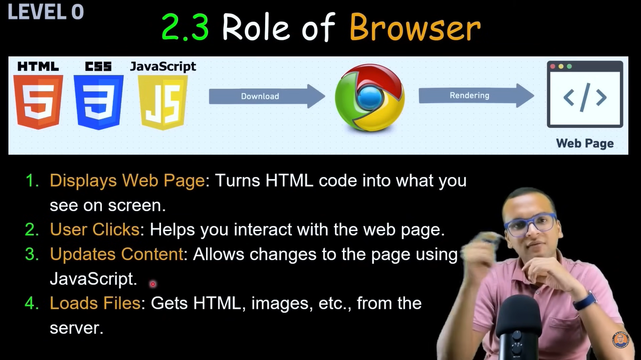

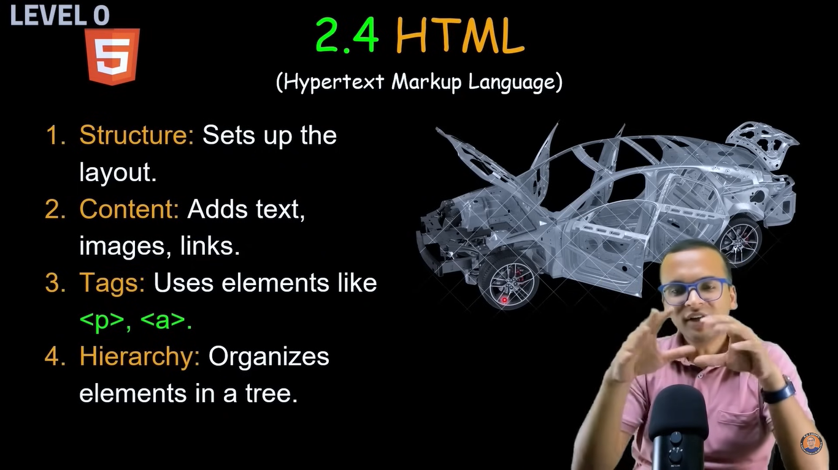

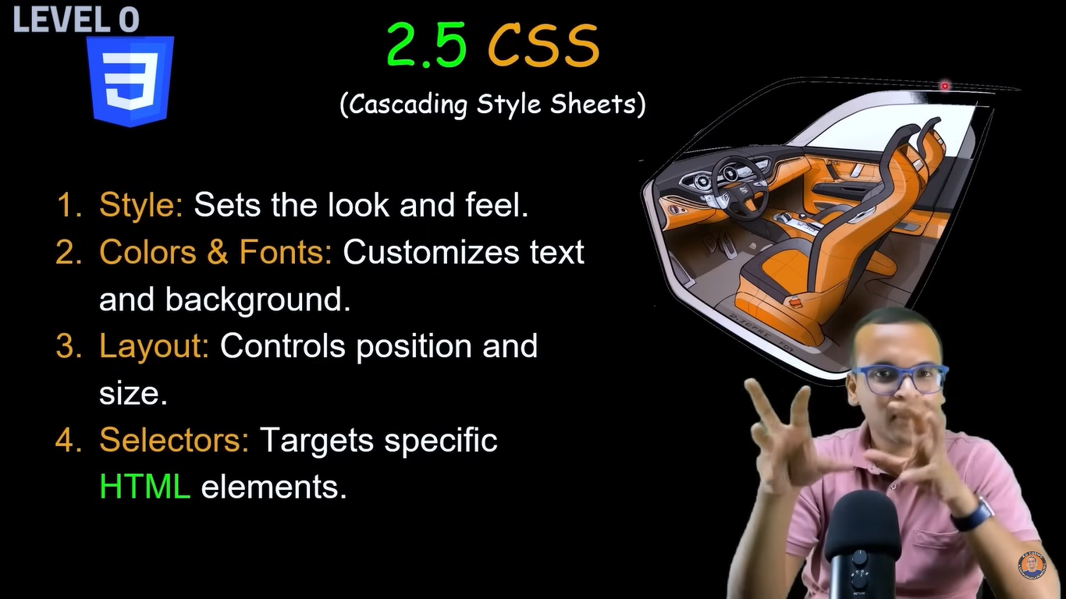

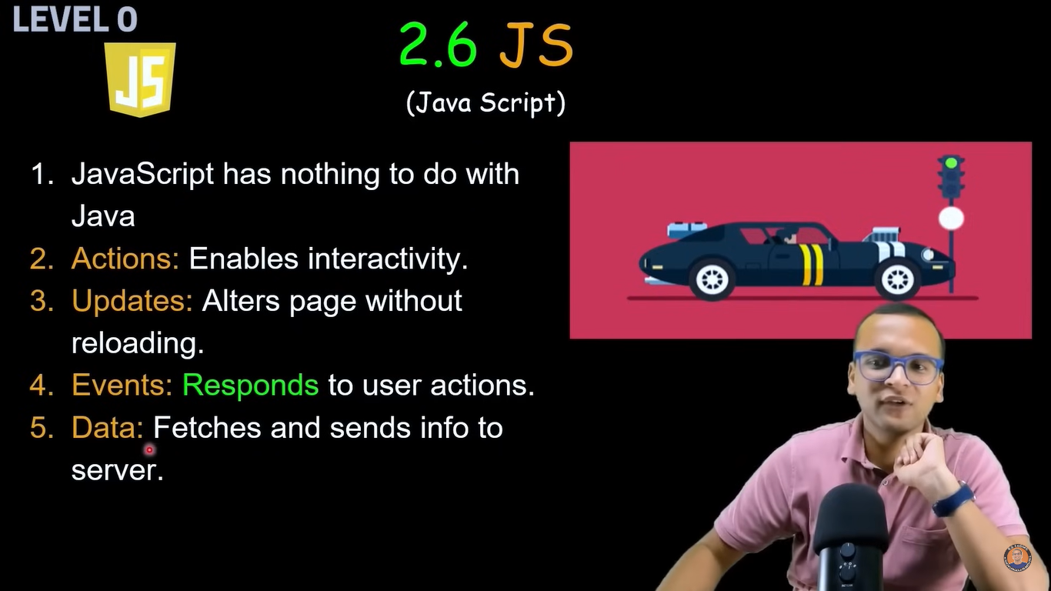

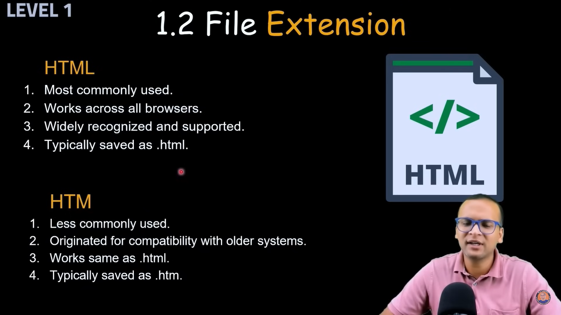

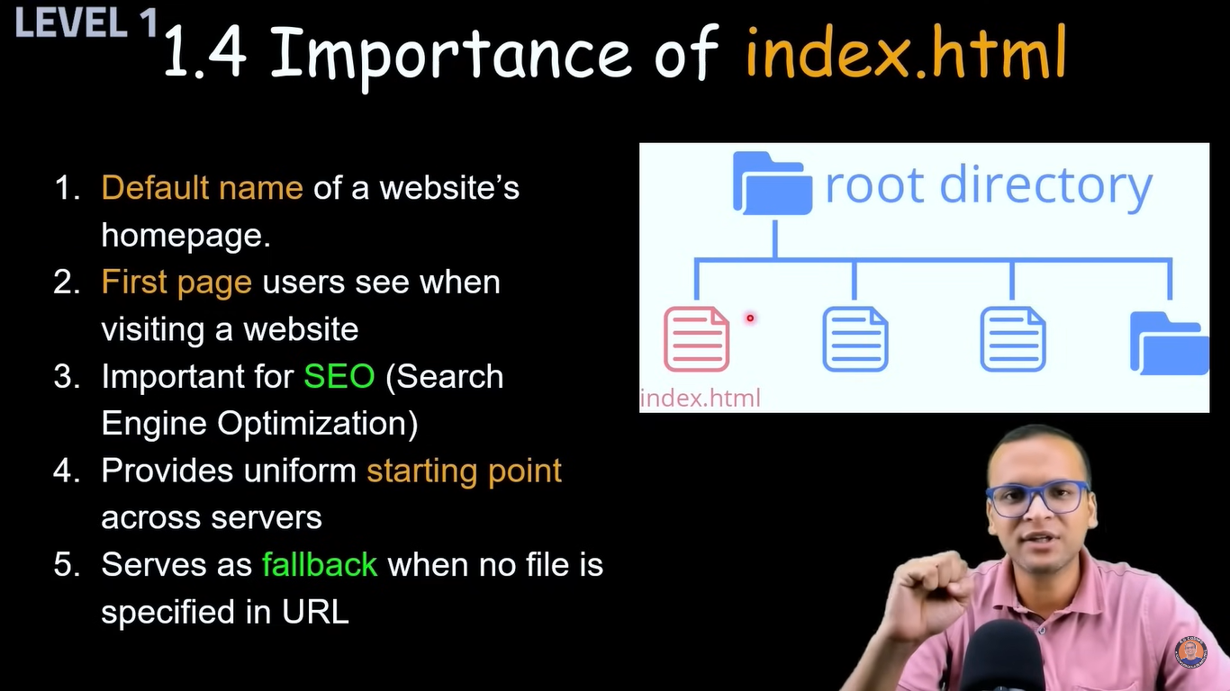

Always store index.html file in root folder, it is opening page so it should load fast

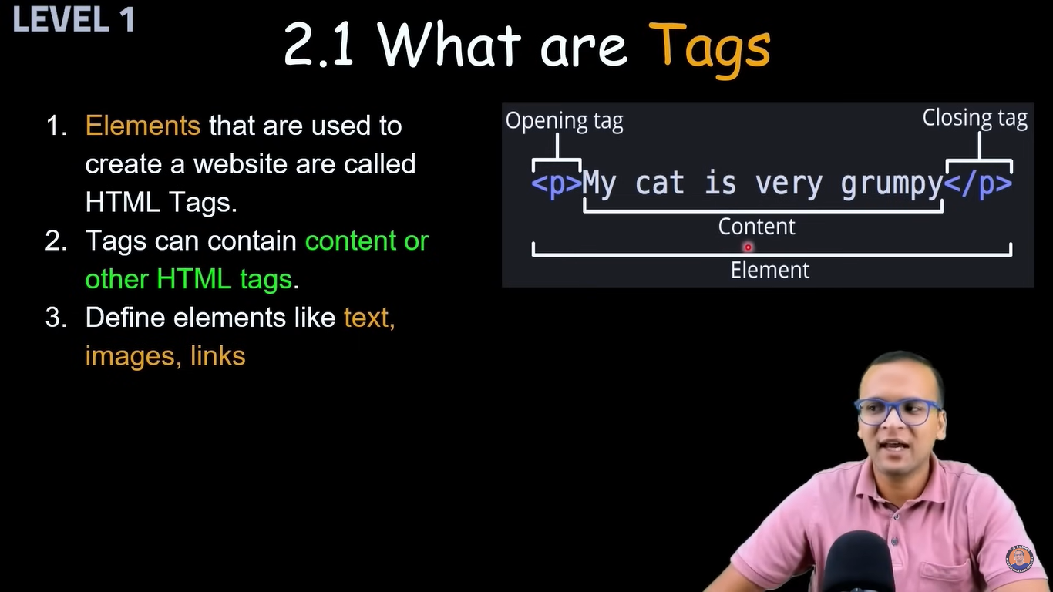



Using ! it will give suggestion to autofill code, so we dont need to write basic code

Ex

<!DOCTYPE html>

<html lang="en">

<head>

<meta charset="UTF-8">

<meta name="viewport" content="width=device-width, initial-scale=1.0">

<title>Document</title>

</head>

<body>

</body>

</html>

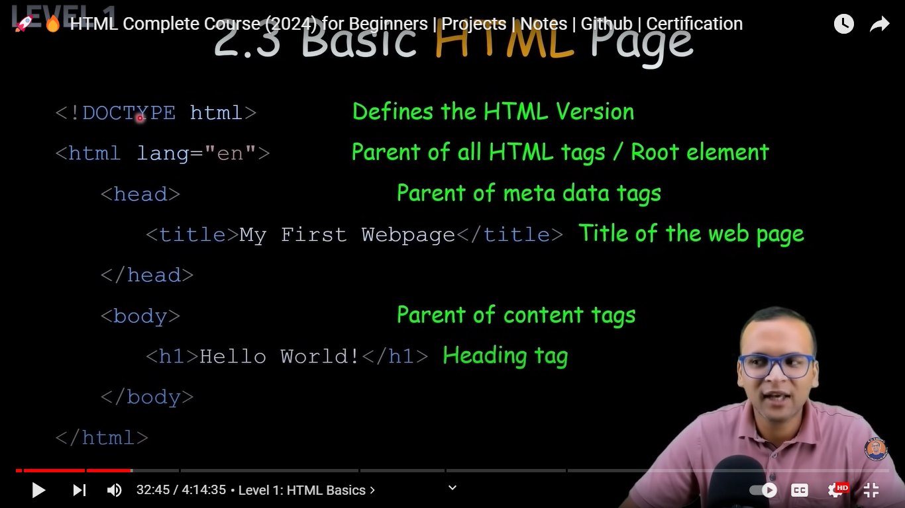

<!DOCTYPE html>

<html lang="en"> –html main start tag

<head> —-- in head we can write title and metadata of page

<meta charset="UTF-8"> —sample metadata

<meta name="viewport" content="width=device-width, initial-scale=1.0">

<title>Title</title>

</head>

<body> —-- from this tag content get start

<h1>This is the index file</h1> —--heading

</body>

</html> —html main end tag



<https://developer.mozilla.org/en-US/docs/Web/HTML>

We can get through cs code, it shows reference

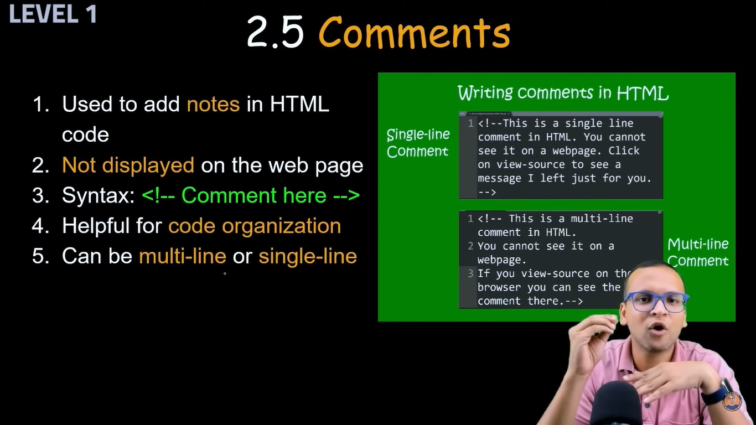

<!DOCTYPE html>

<html lang="en">

<head>

<title>Test</title>

</head>

<body>

<!-- This is sample comment to below header →

<!-- This is sample multi line comment

to below header -->

<h1>This is for comment</h1>

</body>

</html>

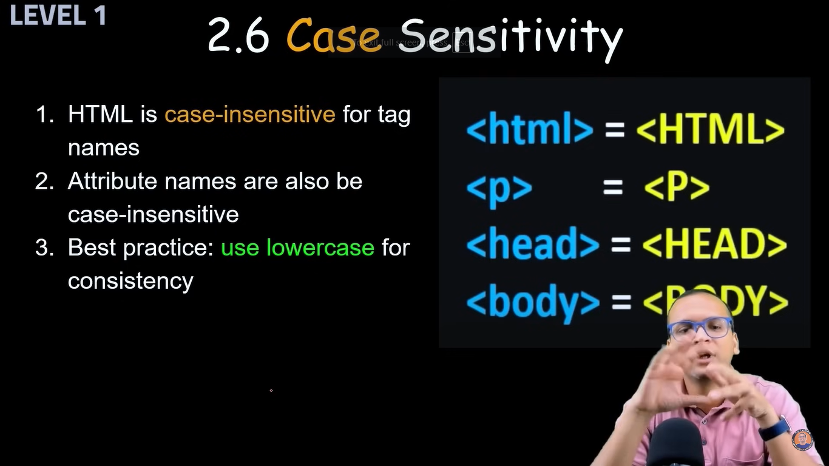

—----------------------------------------------------------------------------------------------------------------------------

**Project 1**

<!-- This is basic project created with emmit '!' and adding basic Title and head

also using comment -->

<!DOCTYPE html>

<html lang="en">

<head>

<meta charset="UTF-8">

<meta name="viewport" content="width=device-width, initial-scale=1.0">

<title>My basic project 1</title>

</head>

<body>

<h1>Learning basic html code </h1>

</body>

</html>

**Tags and Attribs**

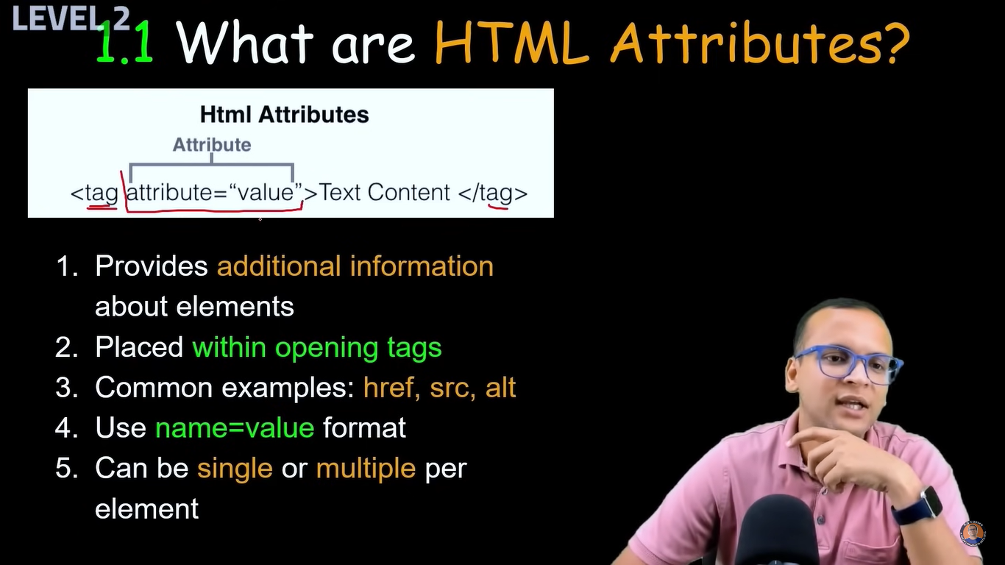



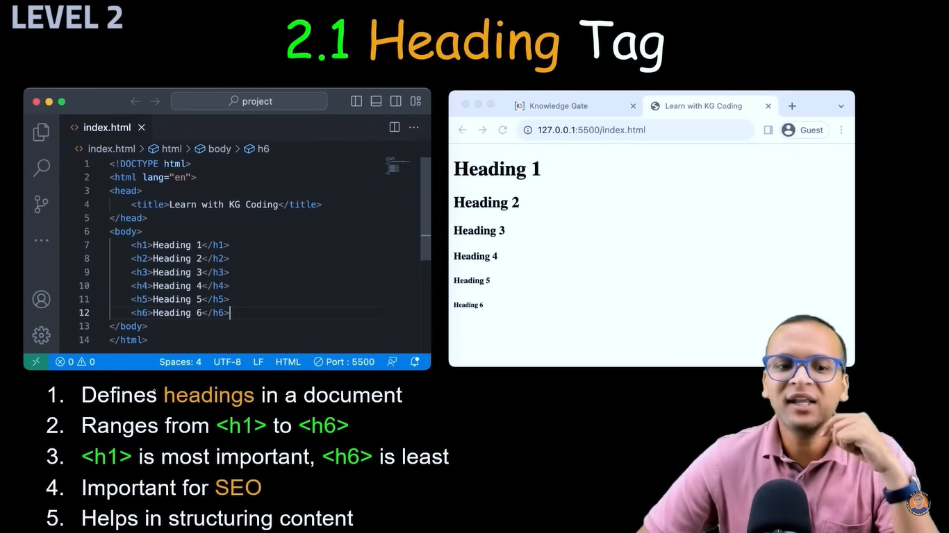

<title>My basic project 1</title>

Title is name that shown at browser tab…. As in above img “Learn with KG Coding” at chrome tab name

<h1>This is the index file</h1>

Head is not related to size of text, it is related to importance of text

H1,h2,h3,h4… it shows importance for size we use CSS

Project2

<!DOCTYPE html>

<html lang="en">

<head>

<meta charset="UTF-8">

<meta name="viewport" content="width=device-width, initial-scale=1.0">

<title>Heading Project</title>

</head>

<body>

<h1>heading 1</h1>

<h2>heading 2</h2>

<h3>heading 3</h3>

<h4>heading 4</h4>

<h5>heading 5</h5>

<h6>heading 6</h6>

</body>

</html>

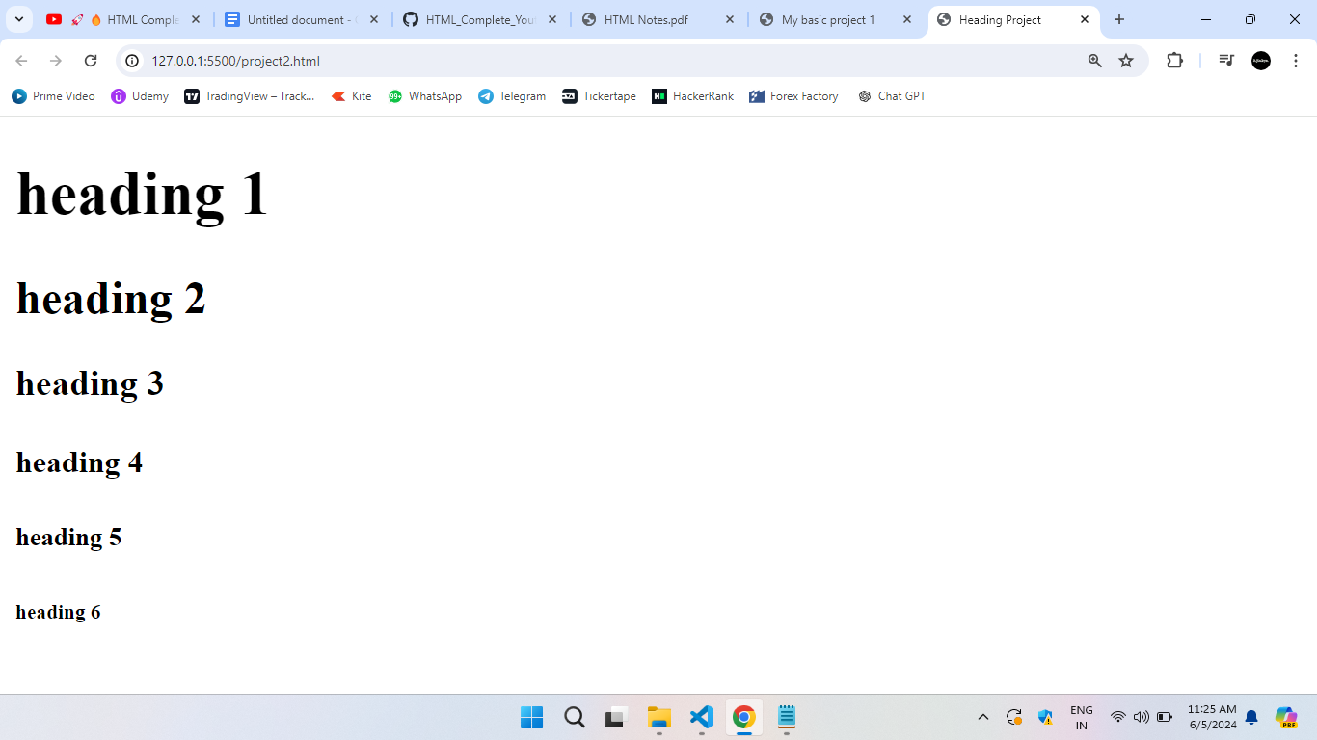

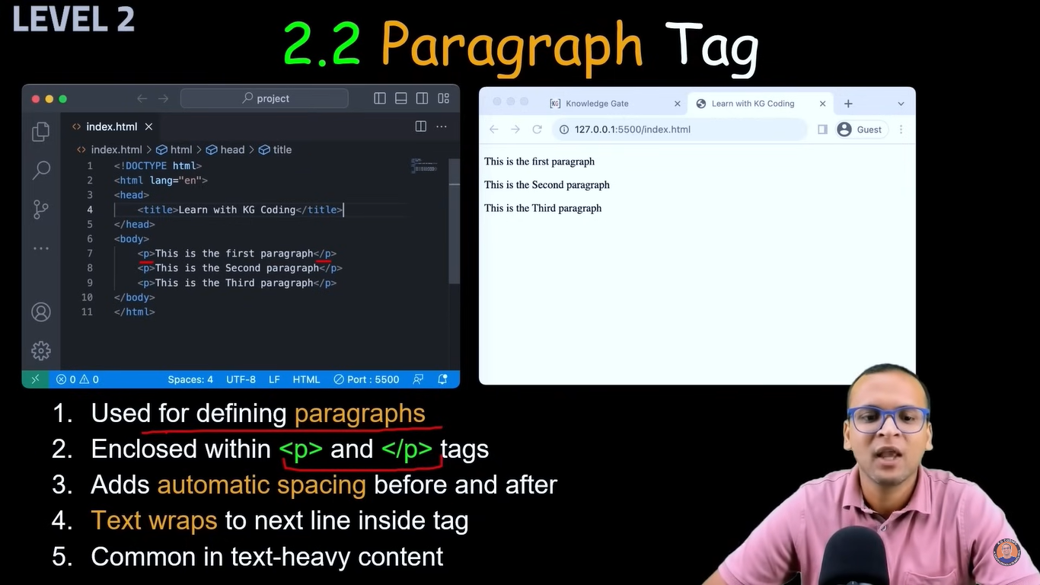

<!DOCTYPE html>

<html lang="en">

<head>

<meta charset="UTF-8">

<meta name="viewport" content="width=device-width, initial-scale=1.0">

<title>Paragraph Project</title>

</head>

<body>

<p>Lorem ipsum dolor sit amet, consectetur adipisicing elit. Perspiciatis reprehenderit aut eligendi saepe quia fuga illo, eius officia repudiandae, molestias veritatis aliquid ipsa molestiae autem accusamus, eum nam odio corrupti.</p>

<p>Lorem ipsum dolor, sit amet consectetur adipisicing elit. Sed, ut rtwdf wegf teufds! </p>

</body>

</html>

In output it gives space in two para

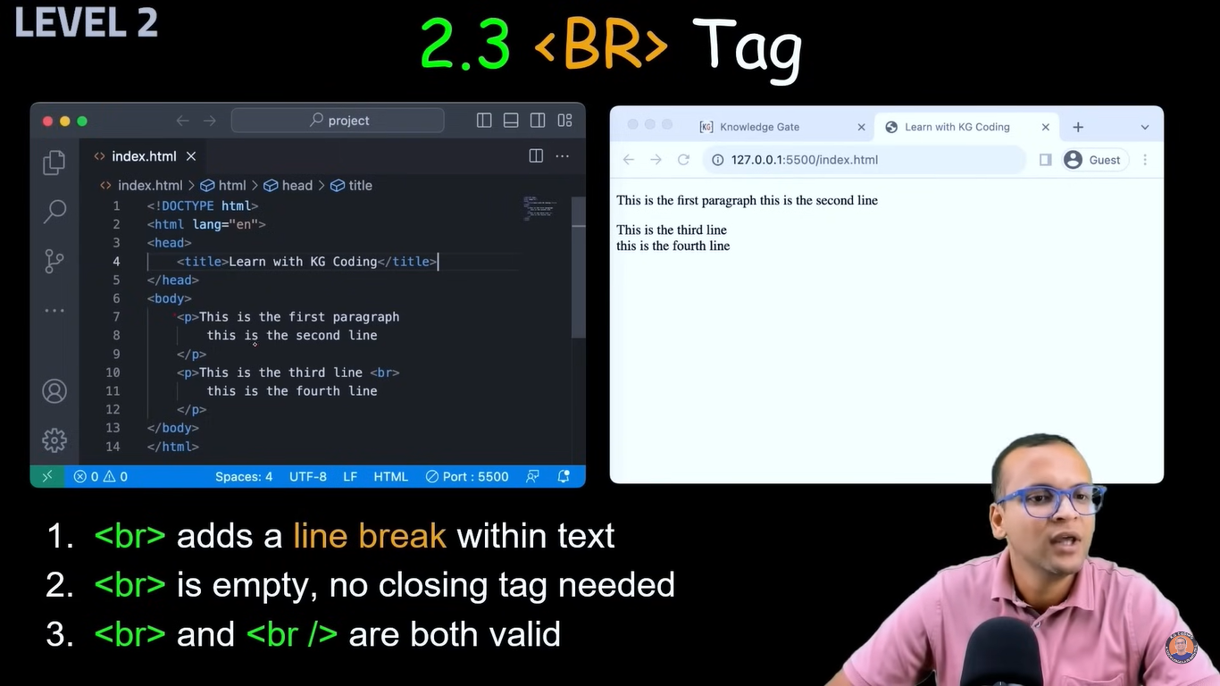

<!DOCTYPE html>

<html lang="en">

<head>

<meta charset="UTF-8">

<meta name="viewport" content="width=device-width, initial-scale=1.0">

<title>Line Brake</title>

</head>

<body>

<p>Lorem ipsum dolor

sit amet consectetur adipisicing elit. <br> Sunt, nulla modi! Nisi sequi voluptatem tenetur? Voluptates paatur debitis dolor consequatur. <br><br><br><br>Incidunt mollitia sunt eaque possimus.</p>

</body>

</html>

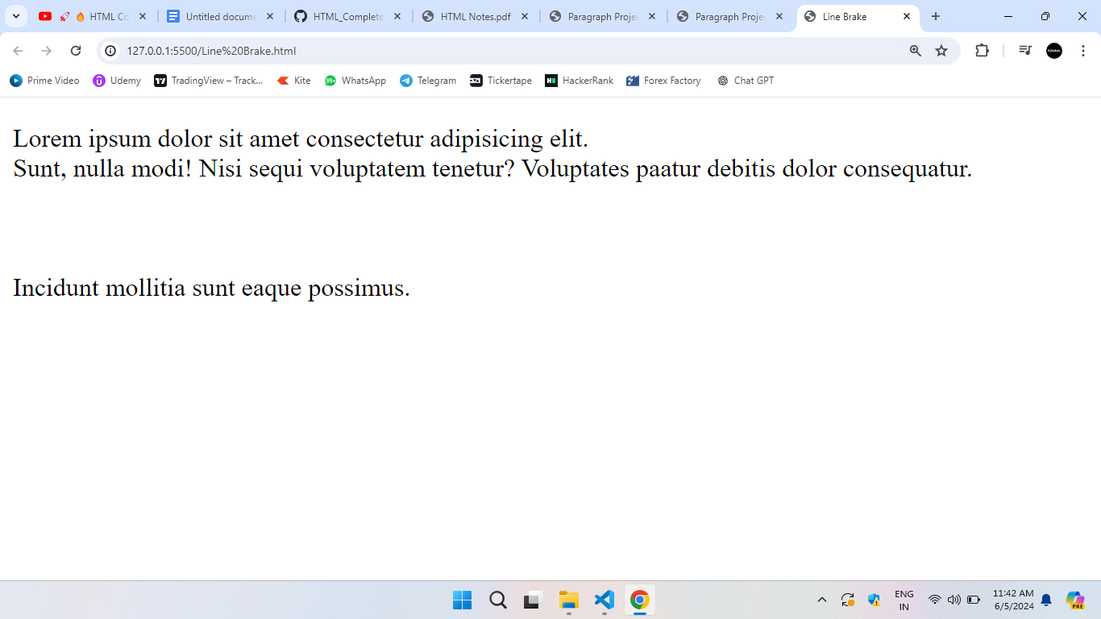

Here we added lot of space after ‘ipsum’ bt it took single space, also we added multiple enter after dolor but it does not take that

But as we add single br it took to next like and as we add 4 br it give that 4 enter space

Br don't have closing tag

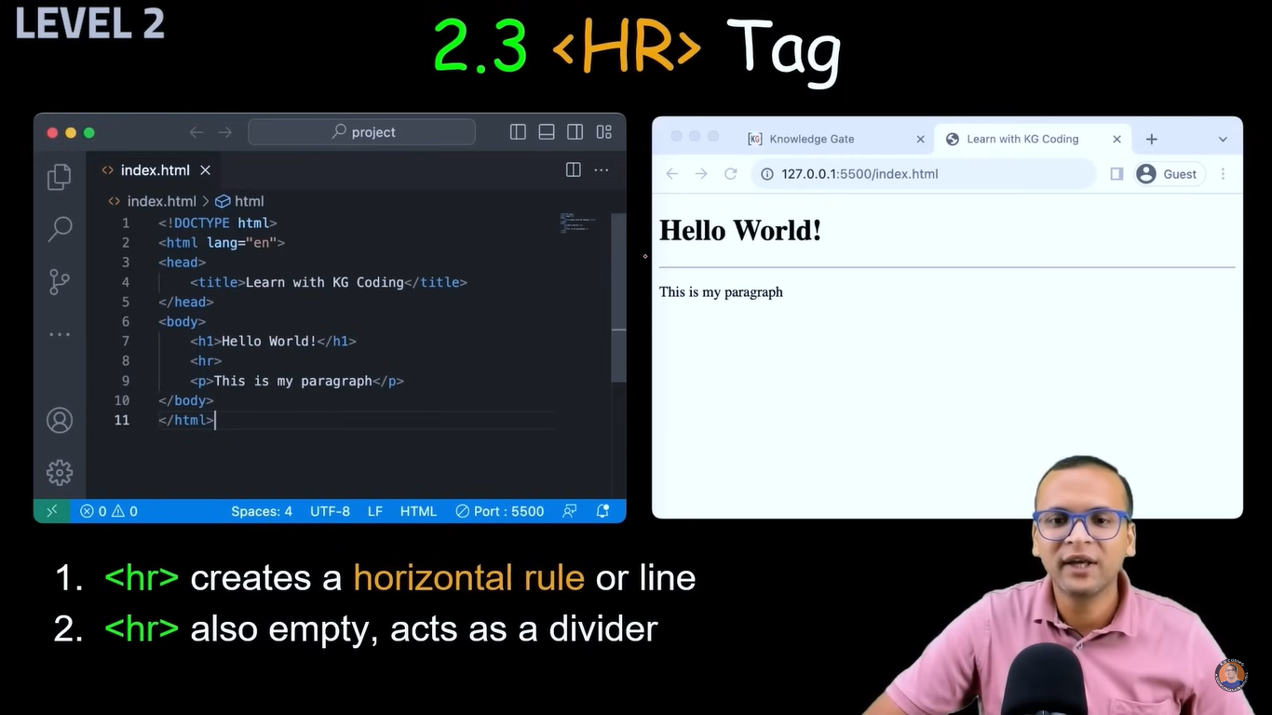

Add horizontal line

<!DOCTYPE html>

<html lang="en">

<head>

<meta charset="UTF-8">

<meta name="viewport" content="width=device-width, initial-scale=1.0">

<title>Adding Horizontal Line</title>

</head>

<body>

<p>Lorem ipsum dolor sit amet consectetur adipisicing elit. <hr> <br> Sunt, nulla modi! Nisi sequi voluptatem tenetur? Voluptates paatur debitis dolor consequatur. <hr><br><br><br><br>Incidunt mollitia sunt eaque possimus.</p>

</body>

</html>

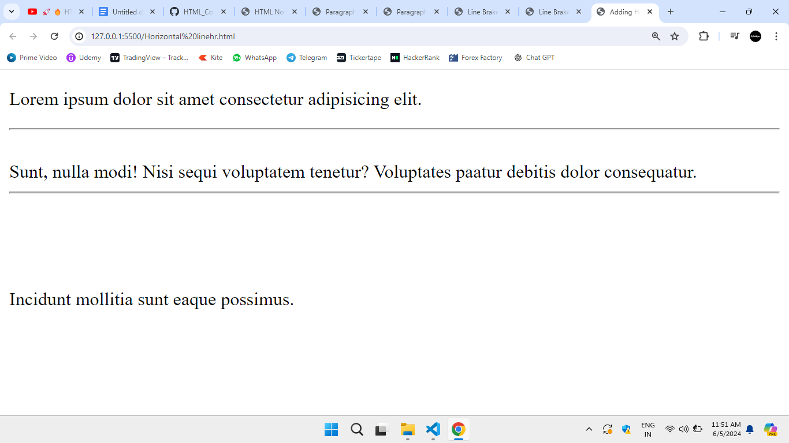



If image and index.html in same folder

<!DOCTYPE html>

<html lang="en">

<head>

<meta charset="UTF-8">

<meta name="viewport" content="width=device-width, initial-scale=1.0">

<title>Image</title>

</head>

<body>

<image src="ajinkya.jpg"

alt="This is Ajinkya's Image"

width="300px" />

</body>

</html>

Here we can mention width and height

If image in another folder called images

<!DOCTYPE html>

<html lang="en">

<head>

<meta charset="UTF-8">

<meta name="viewport" content="width=device-width, initial-scale=1.0">

<title>Image</title>

</head>

<body>

<image src="images/ajinkya.jpg"

alt="This is Ajinkya's Image"

width="300px" />

</body>

</html>

If image is online also if want to images

<!DOCTYPE html>

<html lang="en">

<head>

<meta charset="UTF-8">

<meta name="viewport" content="width=device-width, initial-scale=1.0">

<title>Image</title>

</head>

<body>

<image src="images/ajinkya.jpg"

alt="This is Ajinkya's Image"

width="300px" />

<image src="paste image address here"

alt="This is online Image"

width="300px" />

</body>

</html>

For video

<!DOCTYPE html>

<html lang="en">

<head>

<meta charset="UTF-8">

<meta name="viewport" content="width=device-width, initial-scale=1.0">

<title>Video</title>

</head>

<body>

<video src="assets/video.mp4"

alt="This is Ajinkya's Video"

width="300px"

autoplay controls loop />

</body>

</html>

We dont keep videos in image folder, we keep in assets folder

With videos we also keep font files, and other heavy files excluding code files

If video is not playing automatically then we can add “muted” and try it

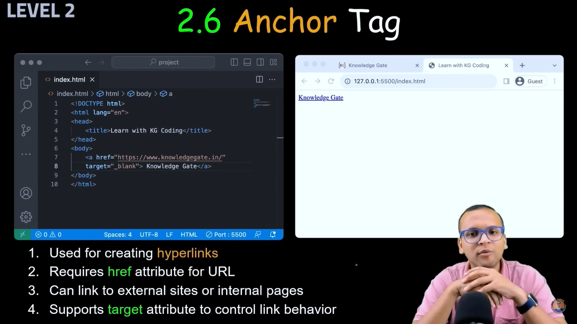

<!DOCTYPE html>

<html lang="en">

<head>

<meta charset="UTF-8">

<meta name="viewport" content="width=device-width, initial-scale=1.0">

<title>Anchor</title>

</head>

<body>

<a href="https://www.instagram.com/"> Click for Instagram</a><br>

<a href="https://www.google.com/"> Click for Google</a><br>

<a href="https://www.facebook.com/"> Click for Facebook</a>

</body>

</html>

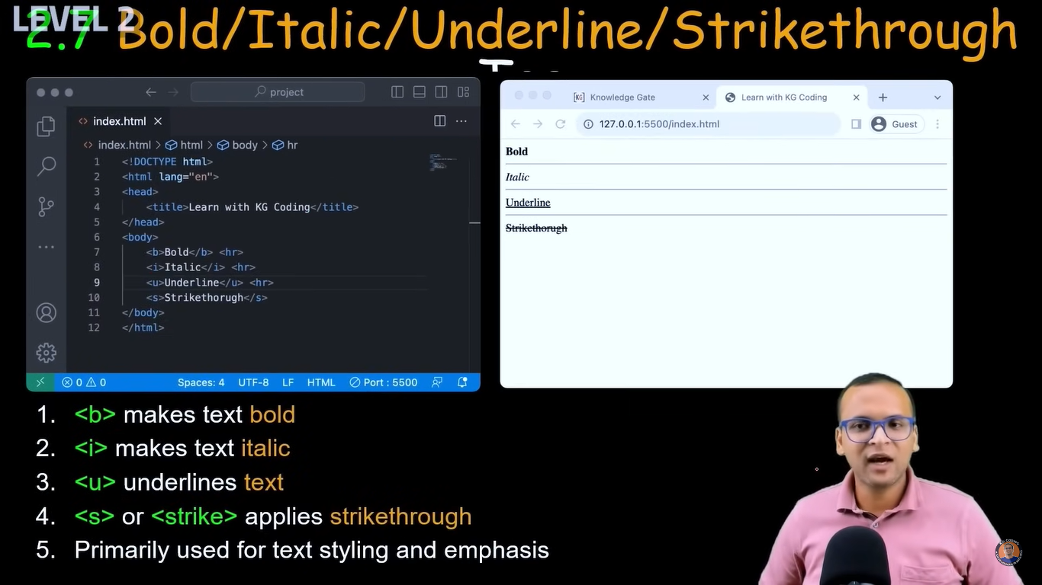

<!DOCTYPE html>

<html lang="en">

<head>

<meta charset="UTF-8">

<meta name="viewport" content="width=device-width, initial-scale=1.0">

<title>Font Style</title>

</head>

<body>

<b>This line is in Bold</b><hr>

<i>This line is in Italic</i><hr>

<u>This line is with Underline</u><hr>

<s>This line is with Strikethrough</s><hr>

</body>

</html>

Hr is used for drawing horizontal line between them

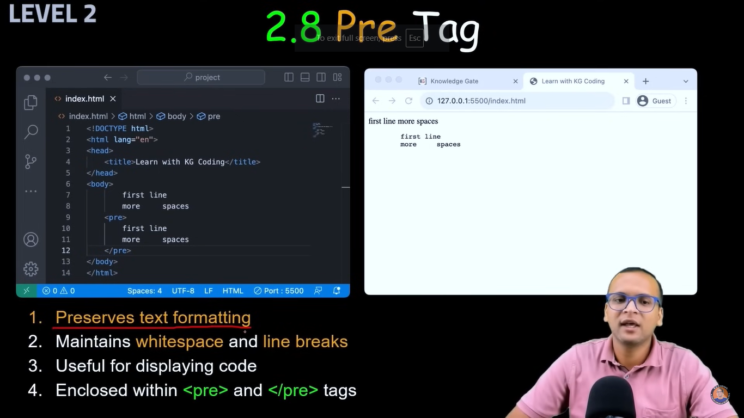

<!DOCTYPE html>

<html lang="en">

<head>

<meta charset="UTF-8">

<meta name="viewport" content="width=device-width, initial-scale=1.0">

<title>Pre Tag</title>

</head>

<body>

this website website

hrhsa hefw

wfhubwuhwf

<pre>the is sfssd

urtto otis

hskashe </pre>

</body>

</html>

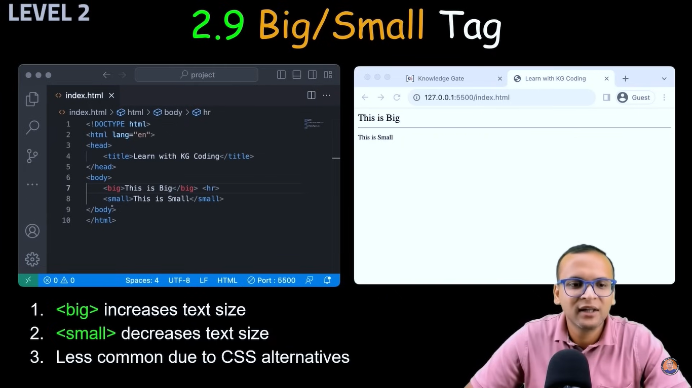

<!DOCTYPE html>

<html lang="en">

<head>

<meta charset="UTF-8">

<meta name="viewport" content="width=device-width, initial-scale=1.0">

<title>Big Small</title>

</head>

<body>

<big>Hello im big</big><br>

<small>Hello im small</small>

</body>

</html>

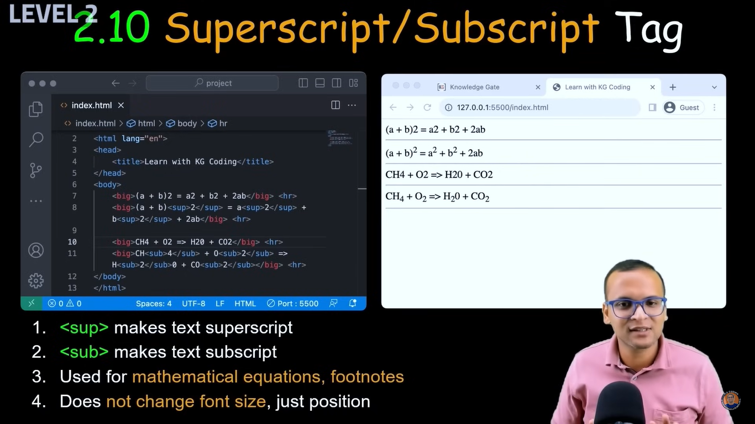

<!DOCTYPE html>

<html lang="en">

<head>

<meta charset="UTF-8">

<meta name="viewport" content="width=device-width, initial-scale=1.0">

<title>Sup Sub</title>

</head>

<body>

(a+b)2= a2+b2+2ab <br><br>

(a+b)<sup>2</sup>=a<sup>2</sup>+b<sup>2</sup>+2ab <br><br>

(a+b)<sub>2</sub>=a<sub>2</sub>+b<sub>2</sub>+2ab

</body>

</html>

<sup> superscript

<sub> subscript

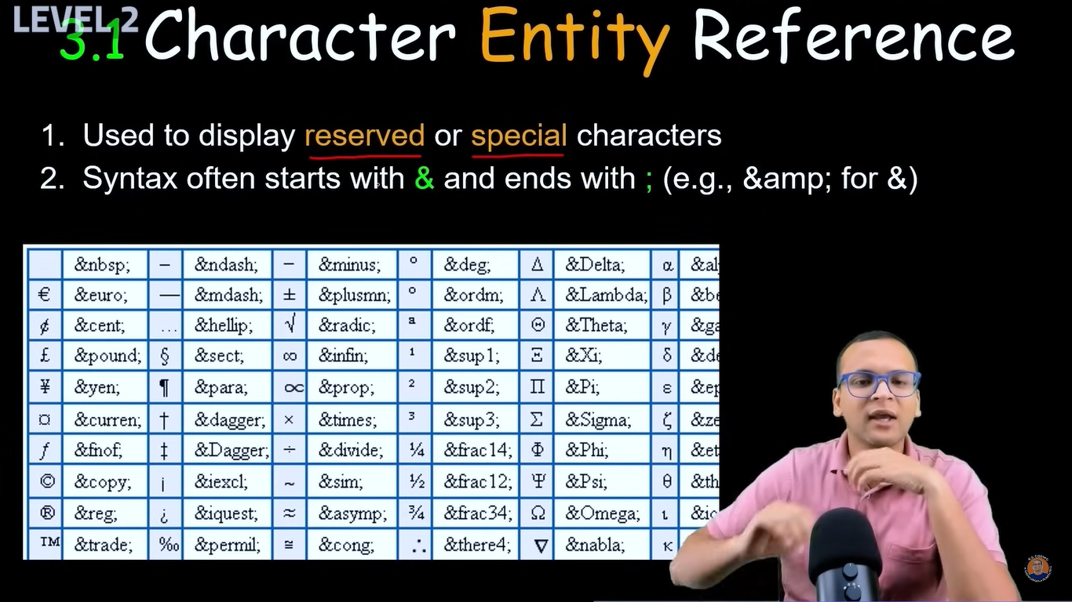

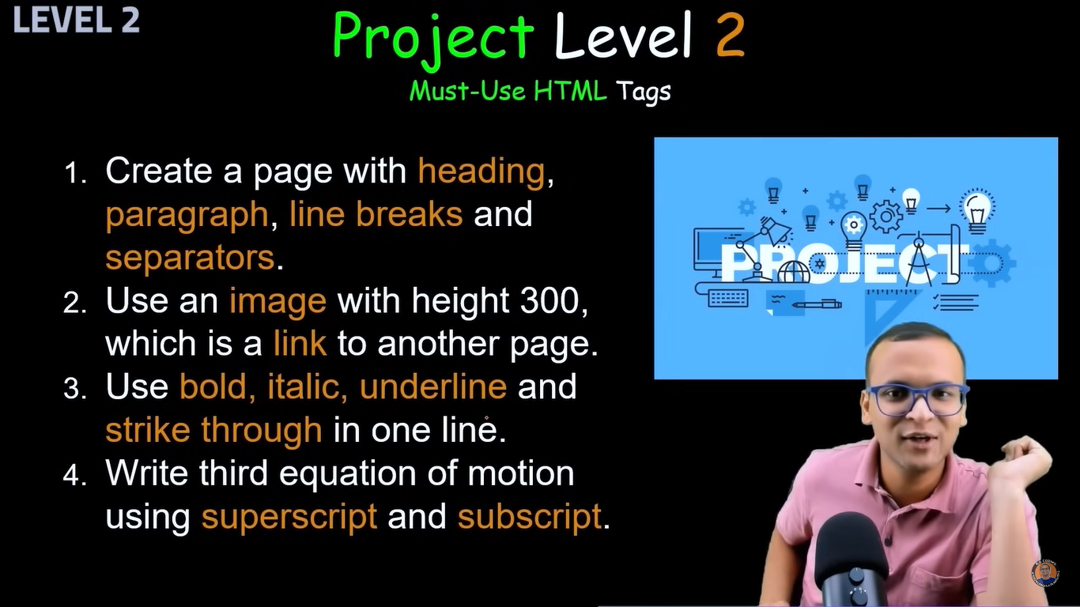

<!DOCTYPE html>

<html lang="en">

<head>

<meta charset="UTF-8">

<meta name="viewport" content="width=device-width, initial-scale=1.0">

<title>Project 2</title>

</head>

<body>

<a href="https://www.fb.com" target="_blank">

<image src="images/ajinkya.jpg"

alt="This is Ajinkya's Image"

height="300px" /> </a><br></a>

<hr>

<p>This is paragraph line </p><br><hr>

<h1>This is heading h1</h1><br>

<h4>This is heading h4 </h4><hr>

<b>My</b> <i>name</i> <u>is</u> <s>Varesh Patil</s><hr>

C12H22O11 <br>

C<sub>12</sub>H<sub>22</sub>O<sub>11</sub> <br>

C<sup>12</sup>H<sup>22</sup>O<sup>11</sup>

</body>

</html>

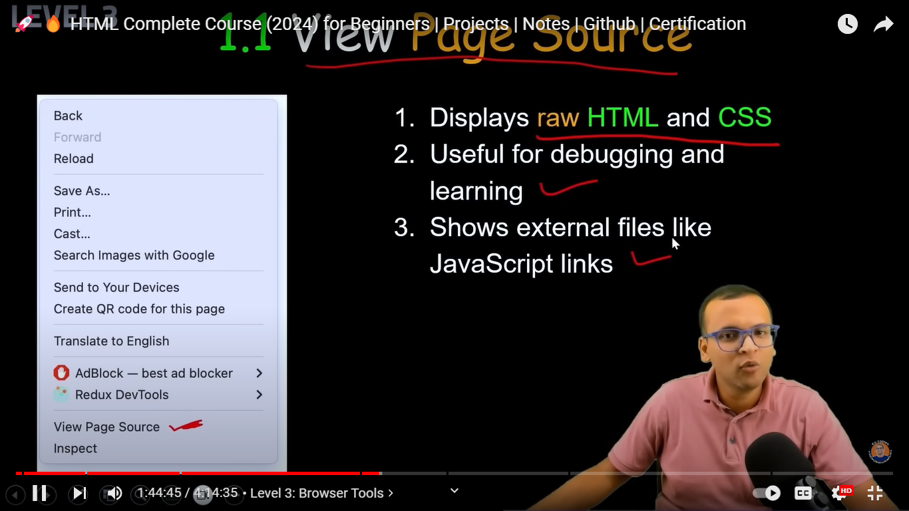

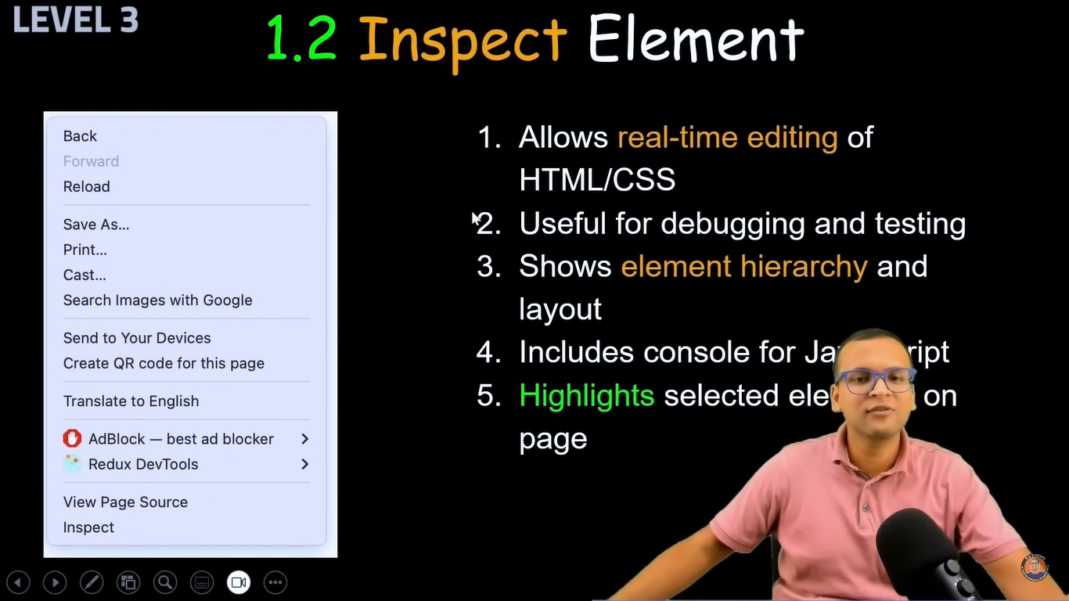

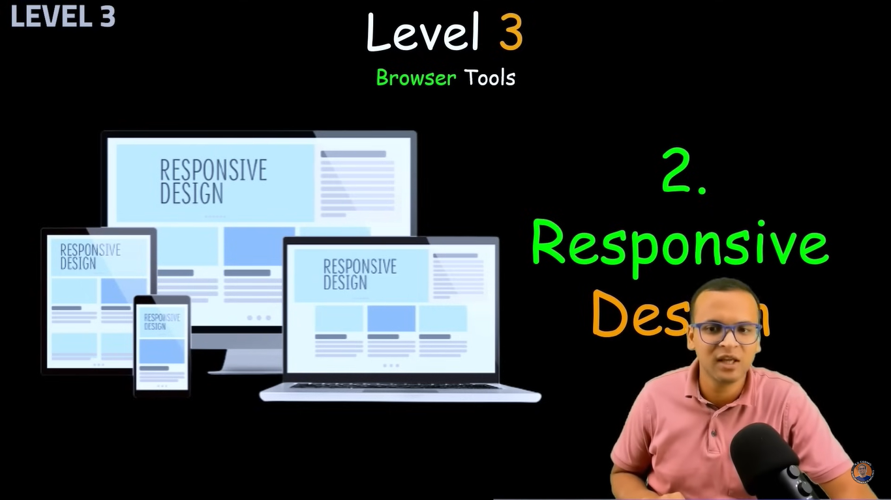

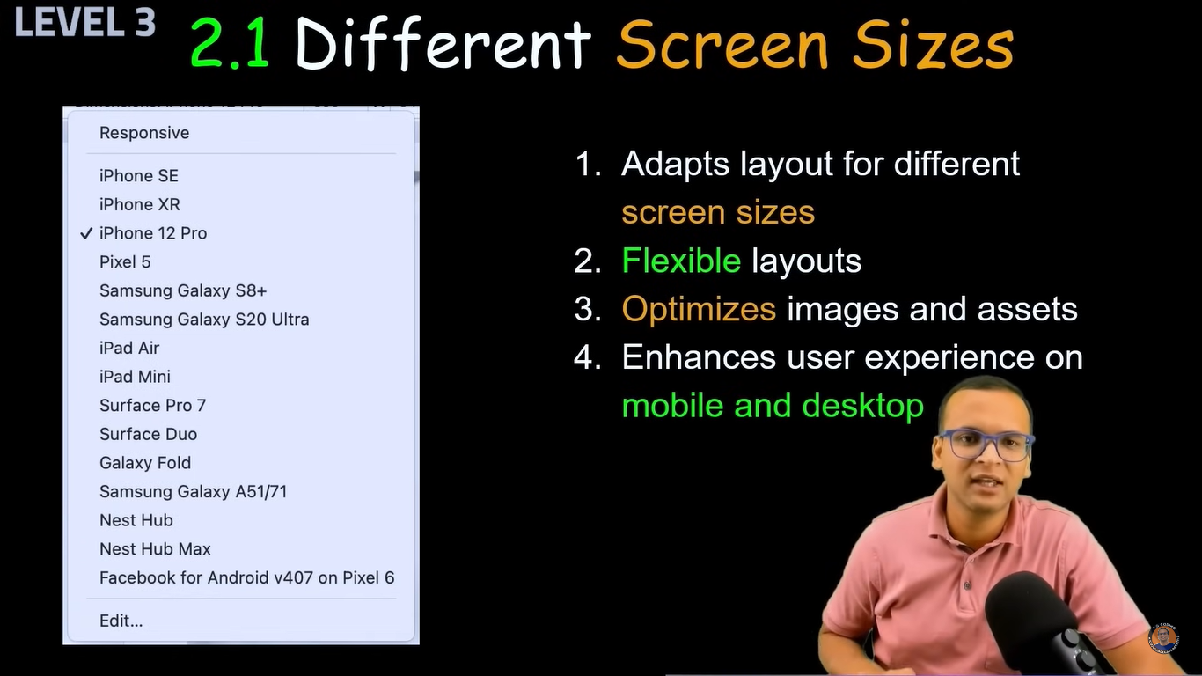



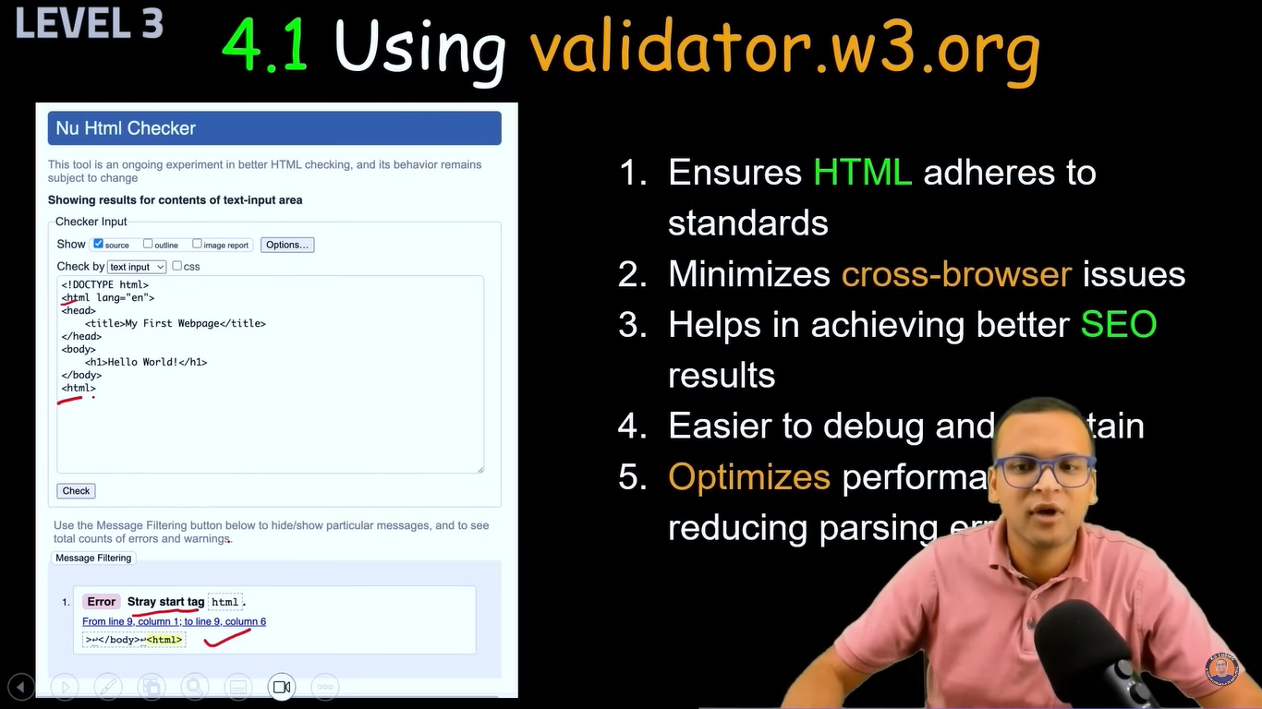

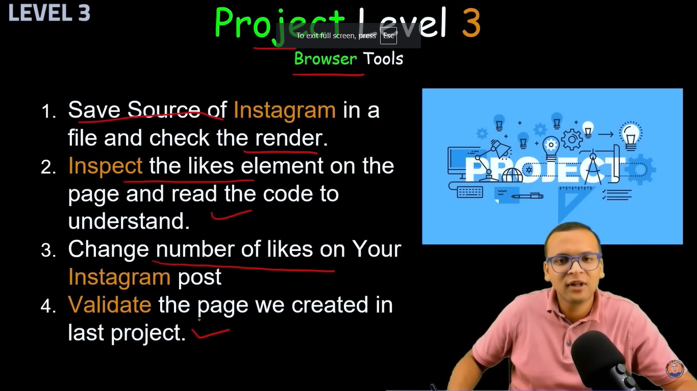

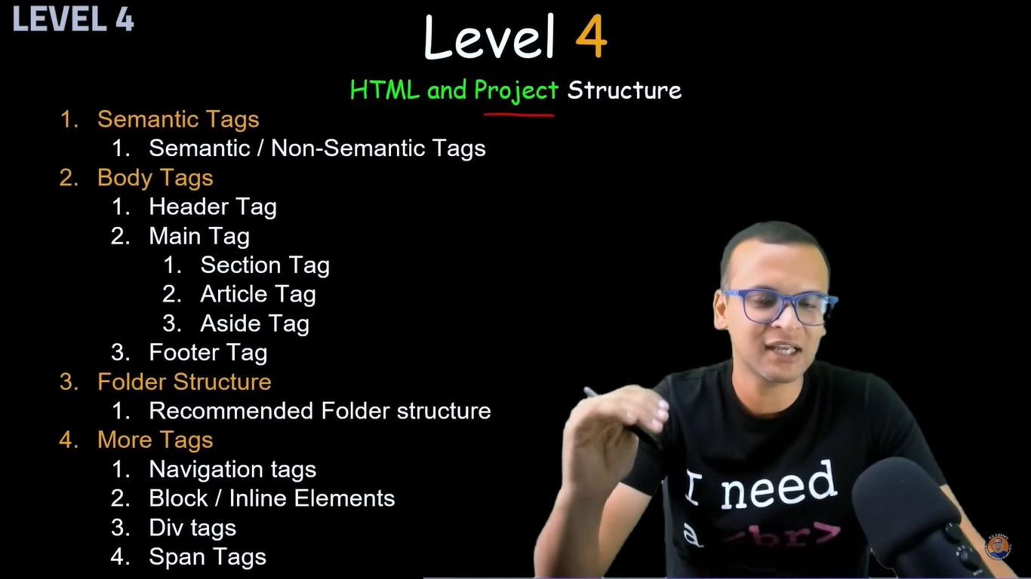

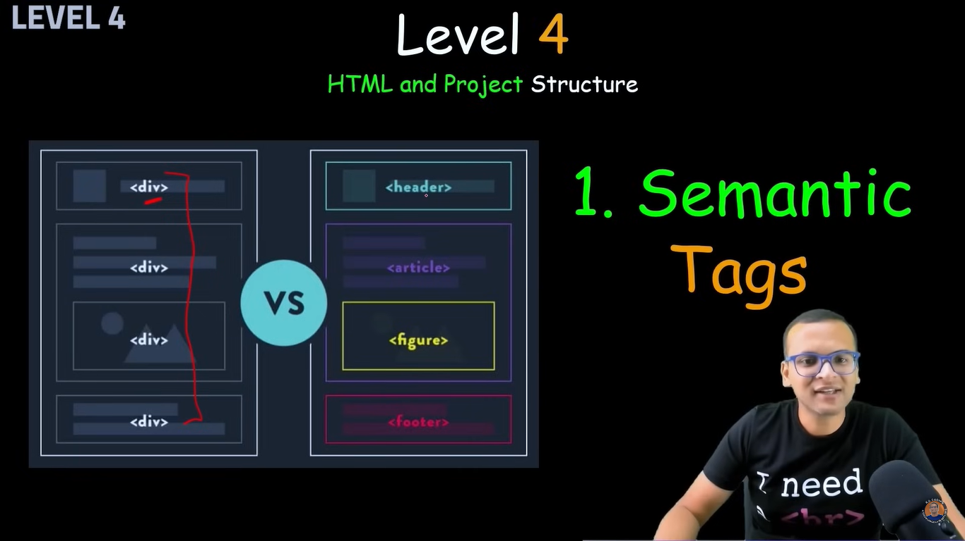

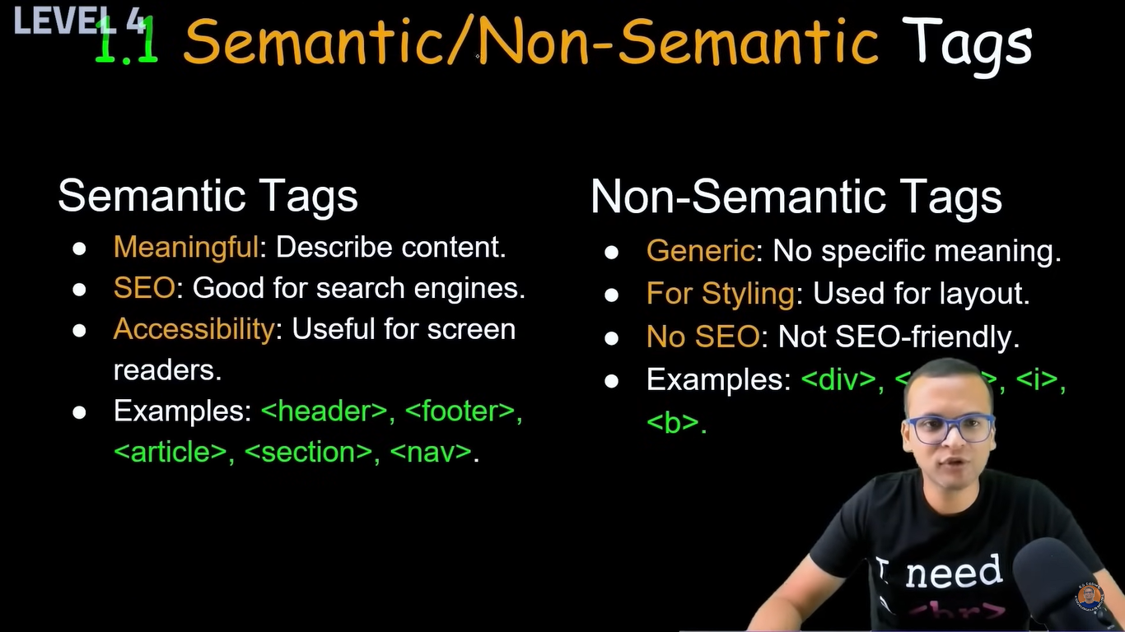

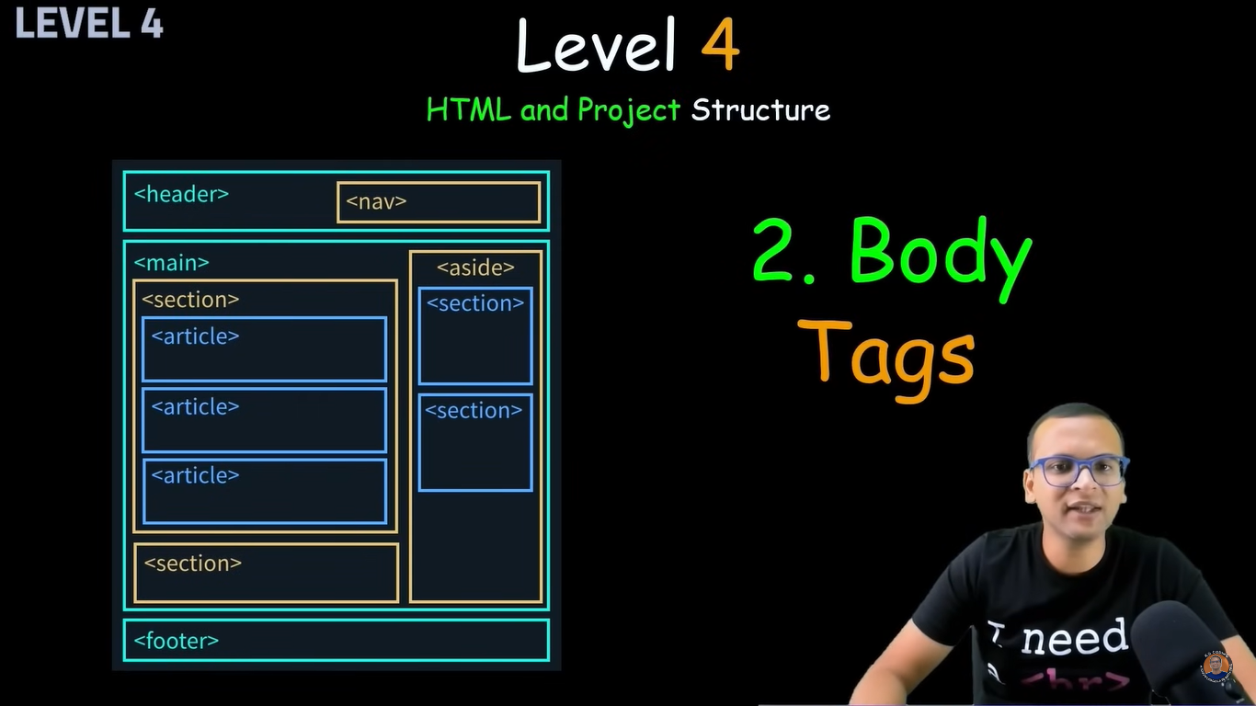

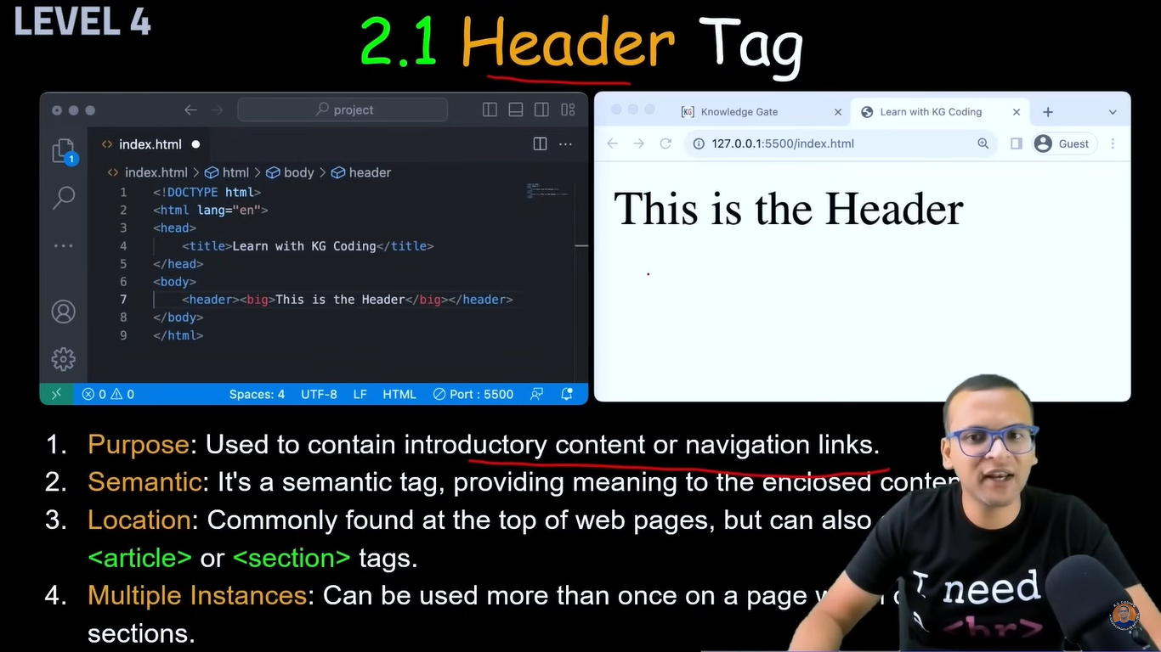

Its good practice to use <big>

<!DOCTYPE html>

<html lang="en">

<head>

<meta charset="UTF-8">

<meta name="viewport" content="width=device-width, initial-scale=1.0">

<title>Header</title>

</head>

<body>

<header><big>This is header</big></header>

</body>

</html>

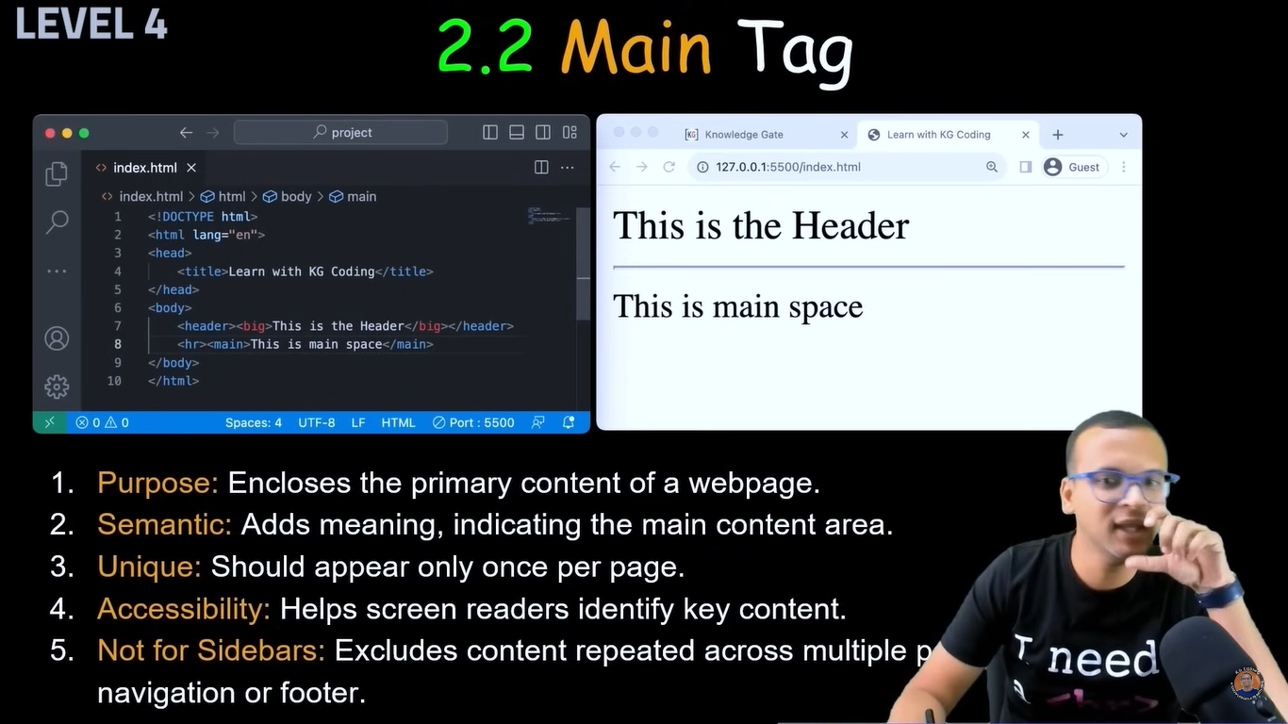

<!DOCTYPE html>

<html lang="en">

<head>

<meta charset="UTF-8">

<meta name="viewport" content="width=device-width, initial-scale=1.0">

<title>main</title>

</head>

<body>

<main>This is main tag</main>

</body>

</html>

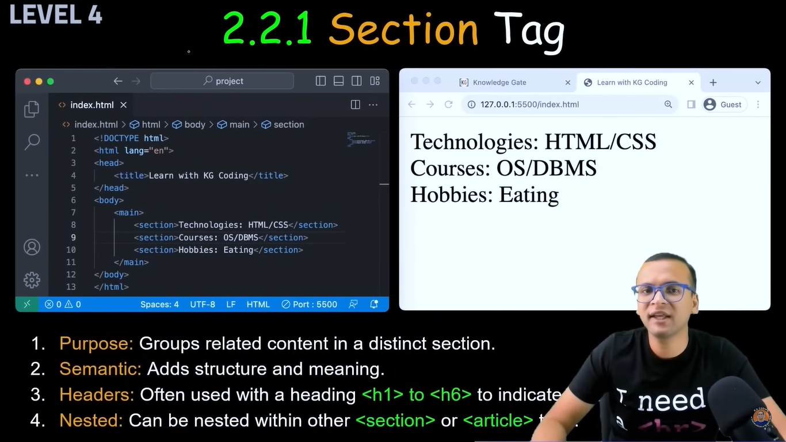

<!DOCTYPE html>

<html lang="en">

<head>

<meta charset="UTF-8">

<meta name="viewport" content="width=device-width, initial-scale=1.0">

<title>Section Tag</title>

</head>

<body>

<main>

<section>Section 1</section>

<section>sec 2</section>

<section>sec 3</section>

</main>

</body>

</html>

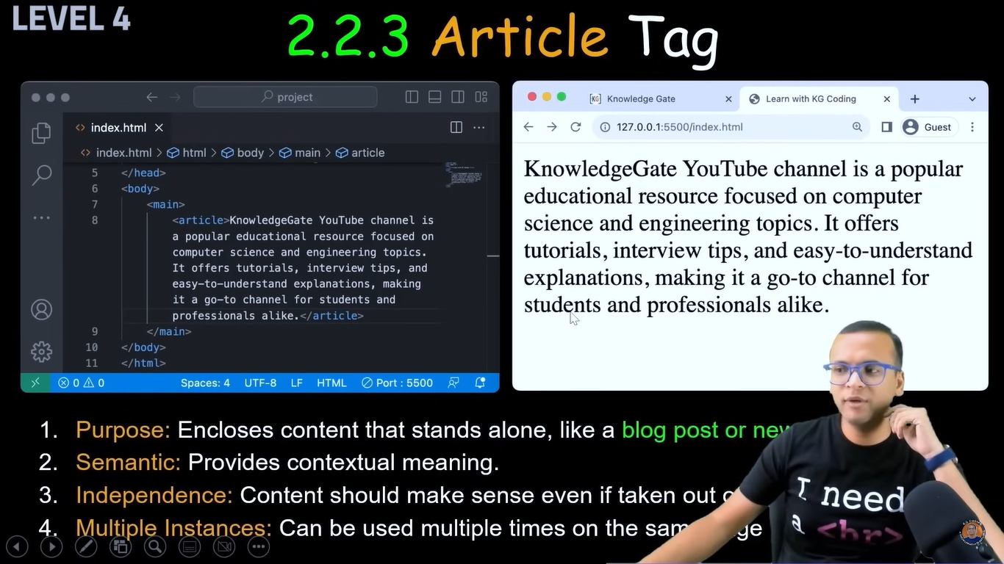

<!DOCTYPE html>

<html lang="en">

<head>

<meta charset="UTF-8">

<meta name="viewport" content="width=device-width, initial-scale=1.0">

<title>Article</title>

</head>

<body>

<main>

<article>

Lorem, ipsum dolor sit amet consectetur adipisicing elit. Eos modi maiores accusantium doloribus officia a cum blanditiis nam amet laudantium?

</article>

</main>

</body>

</html>

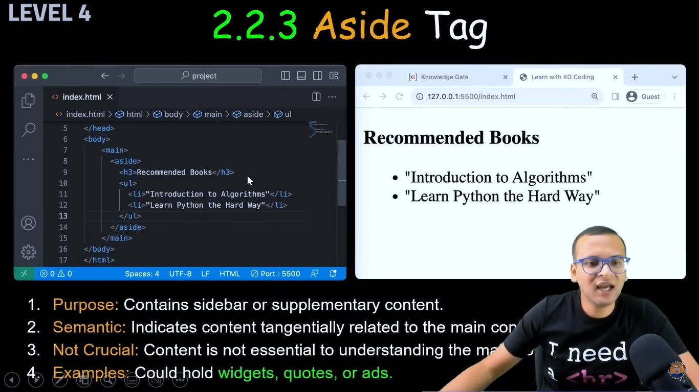

<!DOCTYPE html>

<html lang="en">

<head>

<meta charset="UTF-8">

<meta name="viewport" content="width=device-width, initial-scale=1.0">

<title>Aside Tag</title>

</head>

<body>

<aside>

this is aside tag <br>

gsjhds <br>

hdhd

</aside>

</body>

</html>

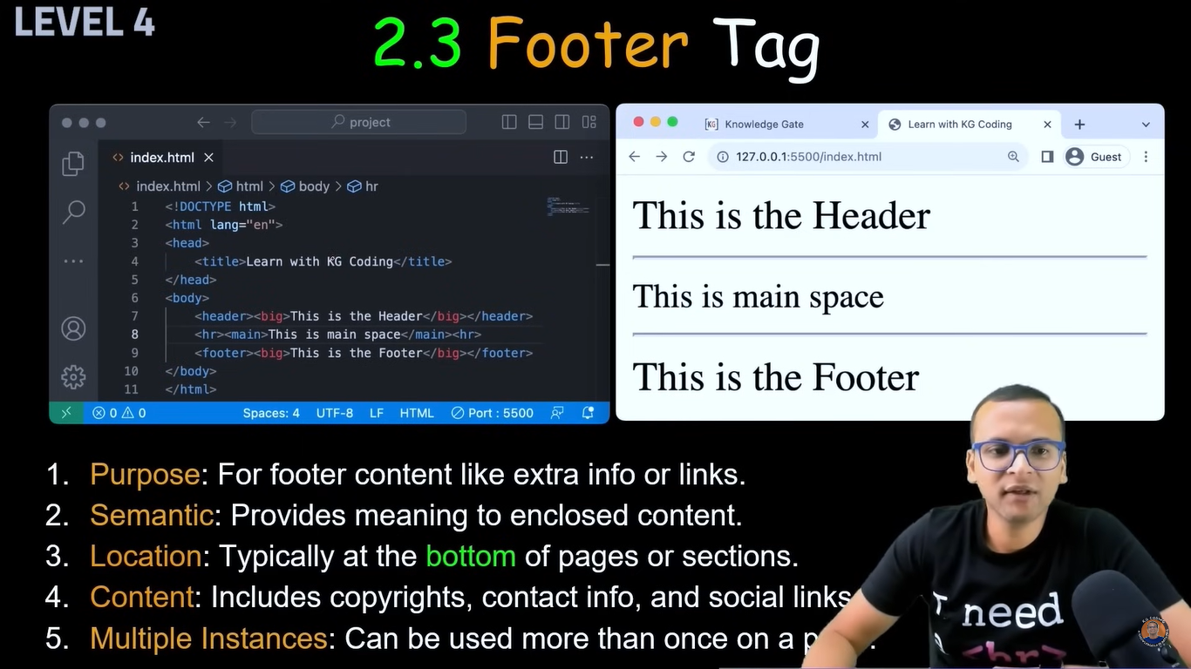

<!DOCTYPE html>

<html lang="en">

<head>

<meta charset="UTF-8">

<meta name="viewport" content="width=device-width, initial-scale=1.0">

<title>Footer</title>

</head>

<body>

<Footer>

this is footer

</Footer>

</body>

</html>

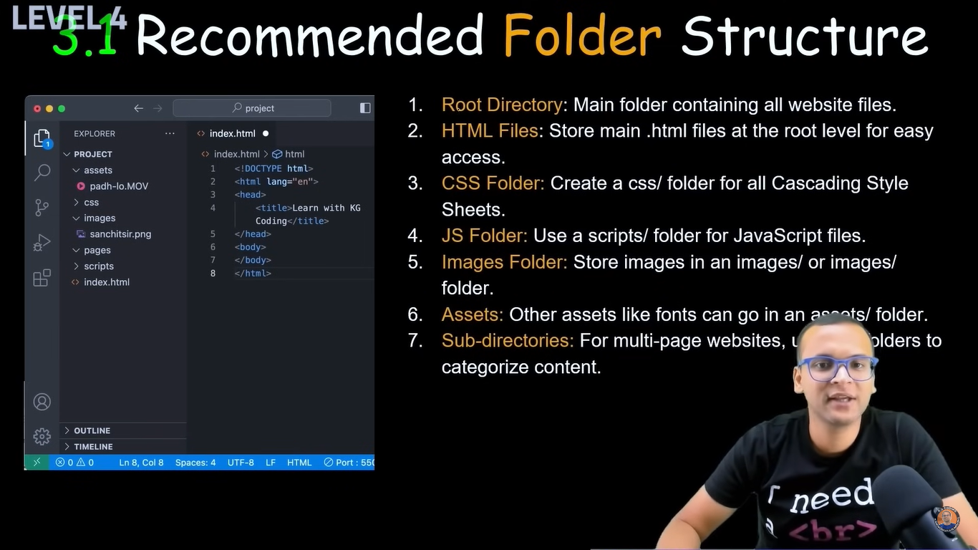

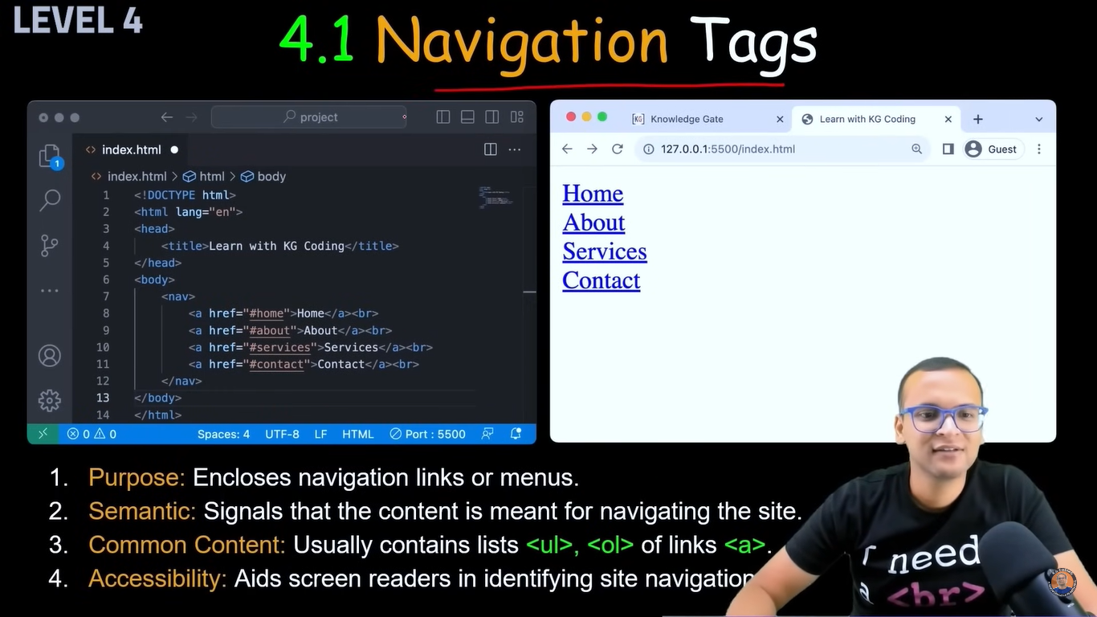

<!DOCTYPE html>

<html lang="en">

<head>

<meta charset="UTF-8">

<meta name="viewport" content="width=device-width, initial-scale=1.0">

<title>Navigation</title>

</head>

<body>

<a href="#Contact">Contact</a>

<p>Lorem ipsum dolor sit amet consectetur adipisicing elit. Eos necessitatibus porro non eum dolorem ex! Doloremque numquam rem non sed id animi quae excepturi repellendus deleniti repellat. Optio, iste deleniti.</p>

<p id="Contact"> Contact: +91 9158147547</p>

</body>

</html>

There contact button will get created, and if we click on contact then it will redirect or navigate to below mentioned contact no.

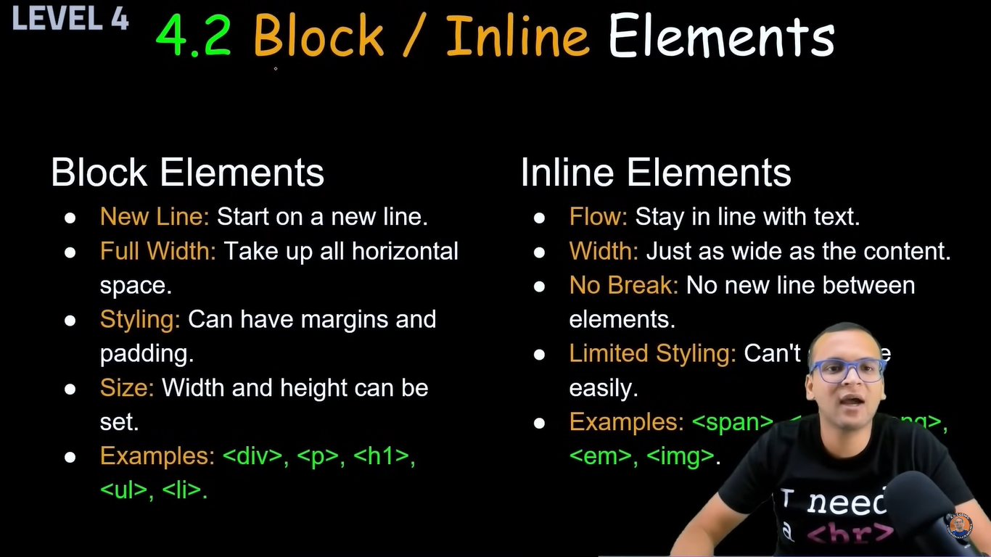

In block element it will consume all horizontal space even if it is blank and it will take next sentence to next line

Ex

I'm ajinkya patil

Im from Islampur

In inline it does not consume blank space, if we add another line with inline element then it will and on same line, will not go to next line

Ex

I'm ajinkya patil Im from Islampur

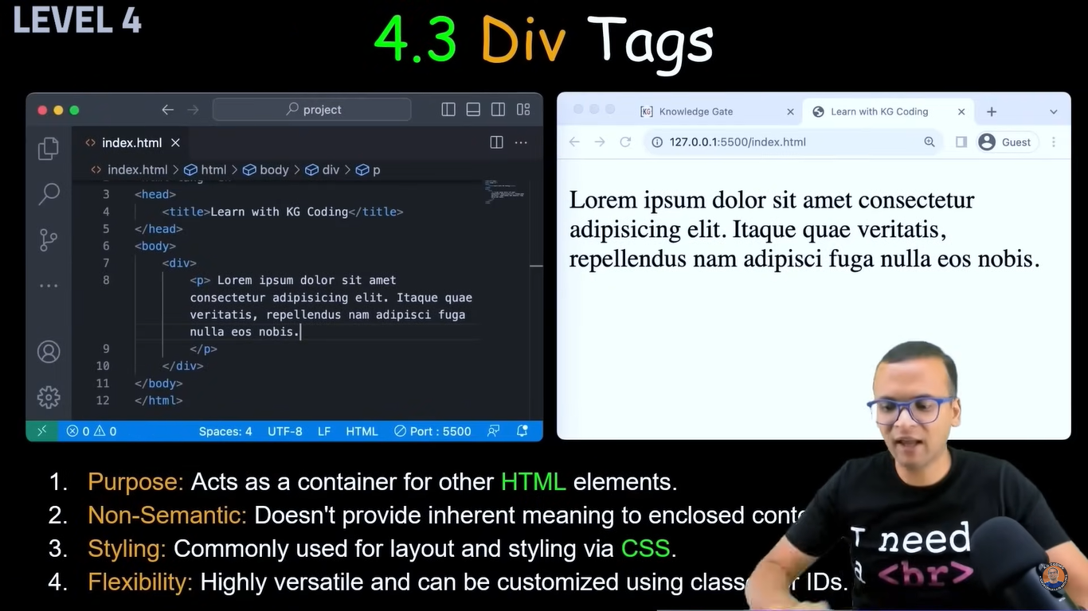

<!DOCTYPE html>

<html lang="en">

<head>

<meta charset="UTF-8">

<meta name="viewport" content="width=device-width, initial-scale=1.0">

<title>Div tag</title>

</head>

<body>

<div>

<p>Im Ajinkya patil</p>

<h1>Im from urun islampur</h1>

</div>

</body>

</html>

When u put content in div then you can add same styling and all other things on div and it will apply on all grp, don't need to apply individually

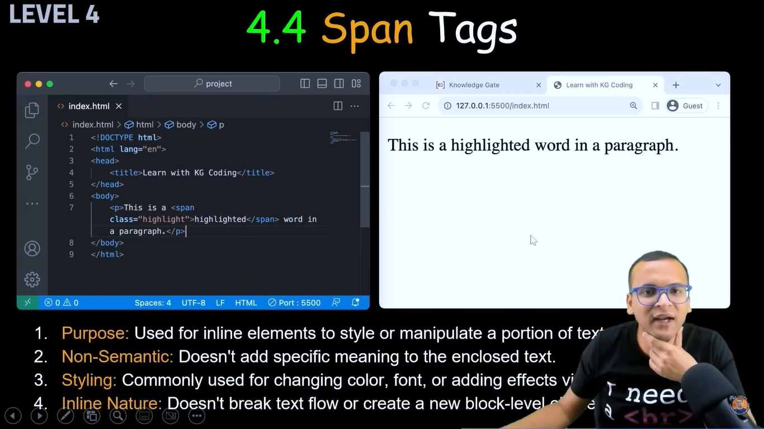

<!DOCTYPE html>

<html lang="en">

<head>

<meta charset="UTF-8">

<meta name="viewport" content="width=device-width, initial-scale=1.0">

<title>Span tag</title>

</head>

<body>

<div>

<p>Im Ajinkya patil, Im from <span>urun islampur</span></p>

</div>

</body>

</html>

Without span it will consider it as one line due to div grouping

But due to span it will break urun ismapur separate so we can do many css changes on it, like color or highlight

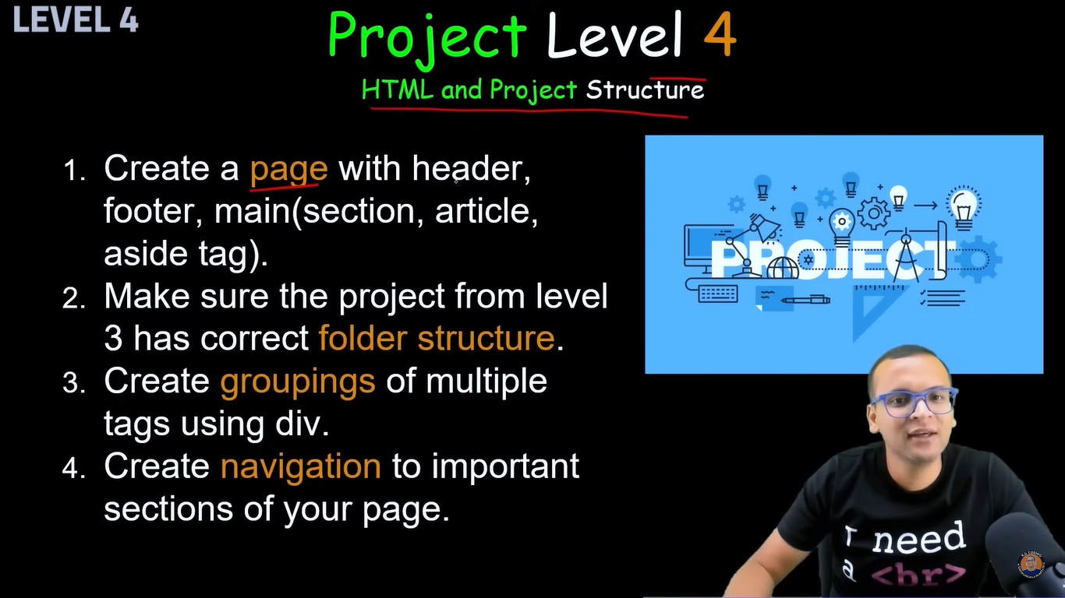

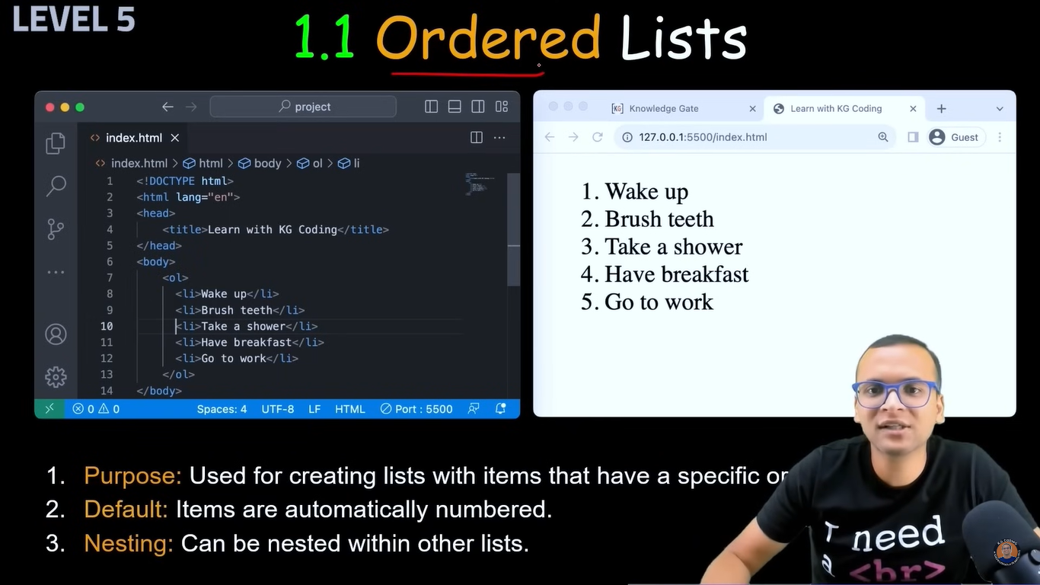

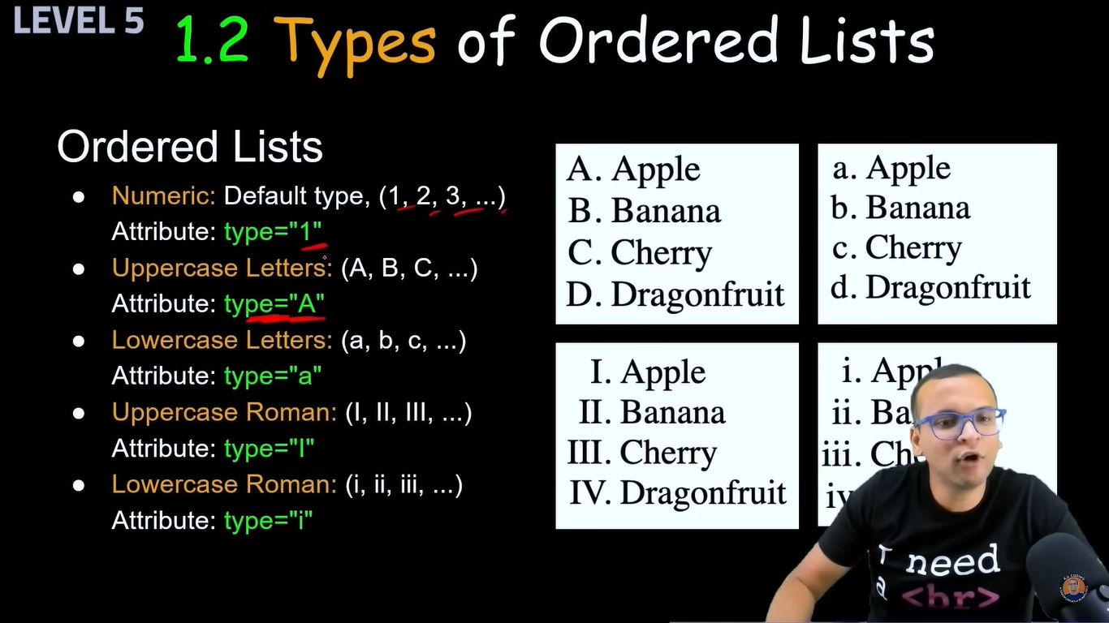

<!DOCTYPE html>

<html lang="en">

<head>

<meta charset="UTF-8">

<meta name="viewport" content="width=device-width, initial-scale=1.0">

<title>Order list</title>

</head>

<body>

<ol>

<li>ABC</li>

<li>BCD</li>

</ol>

<ol type="a">

<li>Patil</li>

<ol type="i">

<li>Ankush</li>

<li>Ajinkya</li>

<li>Amit</li>

</ol>

<li>yadav</li>

<li>jadhav</li>

</ol>

</body>

</html>

By default it takes 1,2,3,4,....

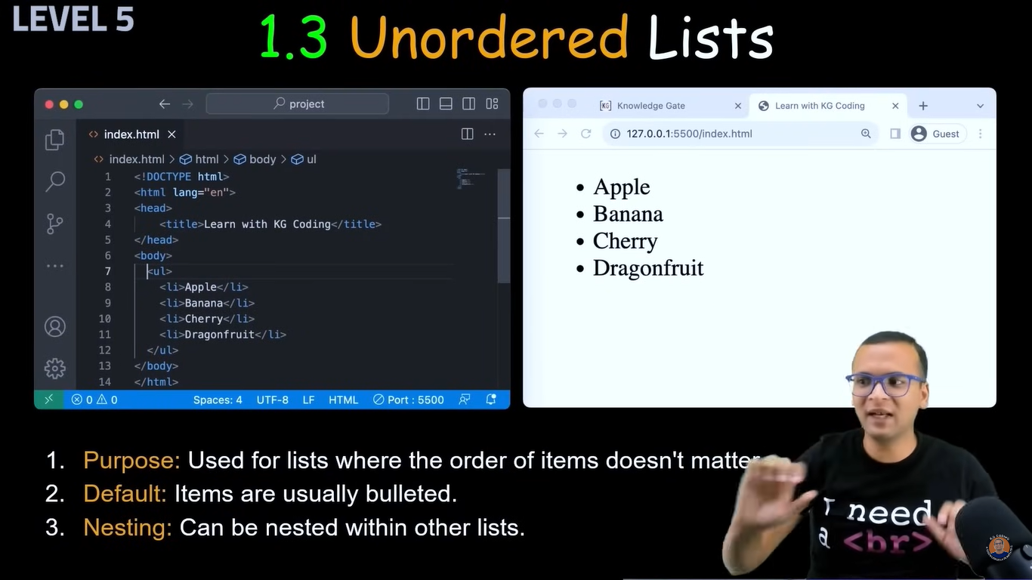

<!DOCTYPE html>

<html lang="en">

<head>

<meta charset="UTF-8">

<meta name="viewport" content="width=device-width, initial-scale=1.0">

<title>unOrder list</title>

</head>

<body>

<ul>

<li>ABC</li>

<li>BCD</li>

</ul>

<ul type="a">

<li>Patil</li>

<ol type="i">

<li>Ankush</li>

<li>Ajinkya</li>

</ol>

<li>yadav</li>

<li>jadhav</li>

</ul>

</body>

</html>

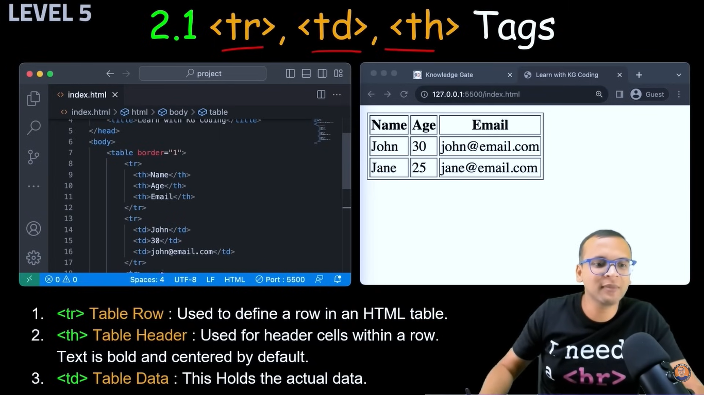

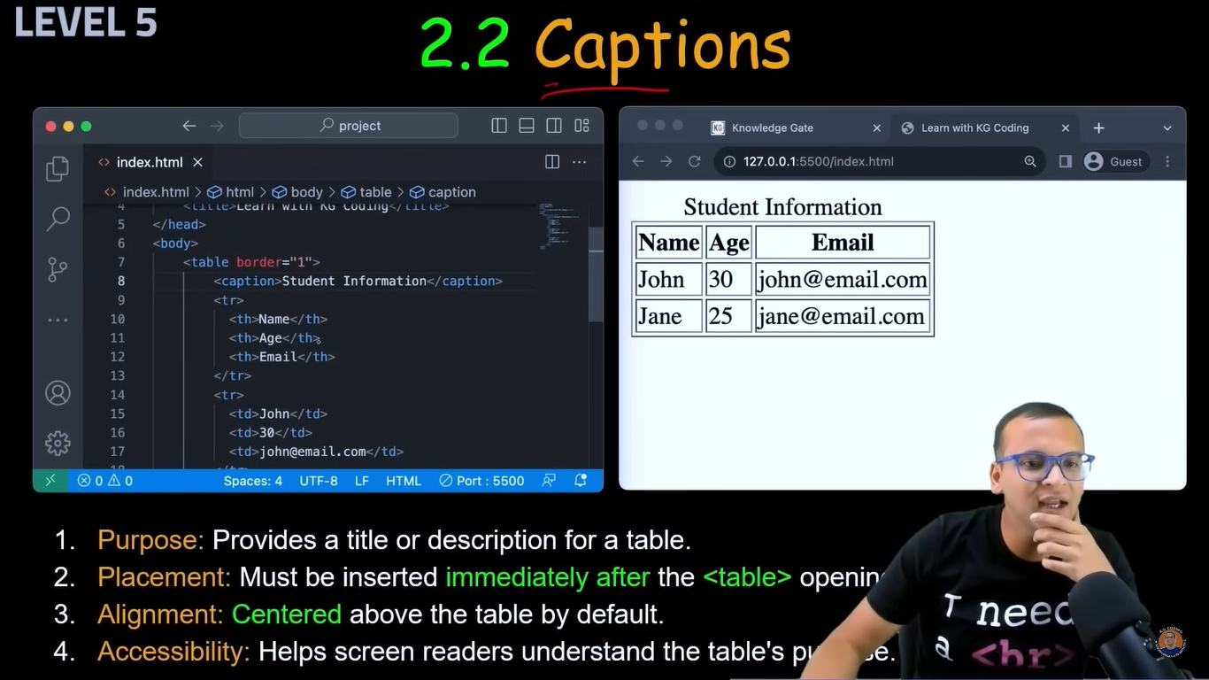

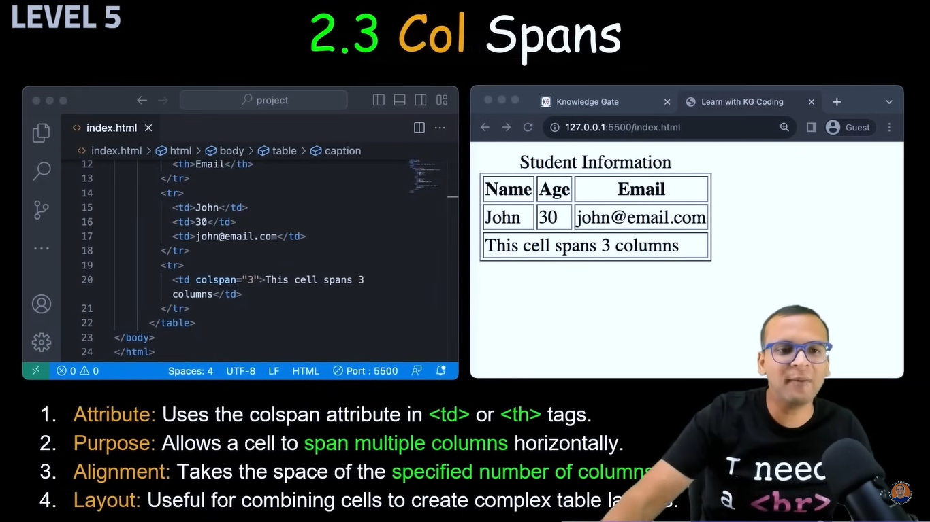

<!DOCTYPE html>

<html lang="en">

<head>

<meta charset="UTF-8">

<meta name="viewport" content="width=device-width, initial-scale=1.0">

<title>Table</title>

</head>

<body>

<table border="1">

<caption>Family data</caption>

<tr><th>Sr</th>

<th>Name</th>

<th>Age</th></tr>

<tr><td>1</td><td>Ajinkya</td><td>26</td></tr>

<tr><td>2</td><td>Varesh</td><td>16</td></tr>

<tr><td>3</td><td>Viren</td><td>7</td></tr>

<tr><td colspan="2">taking 2 column span</td><td>28</td></tr>

</table>

</body>

</html>

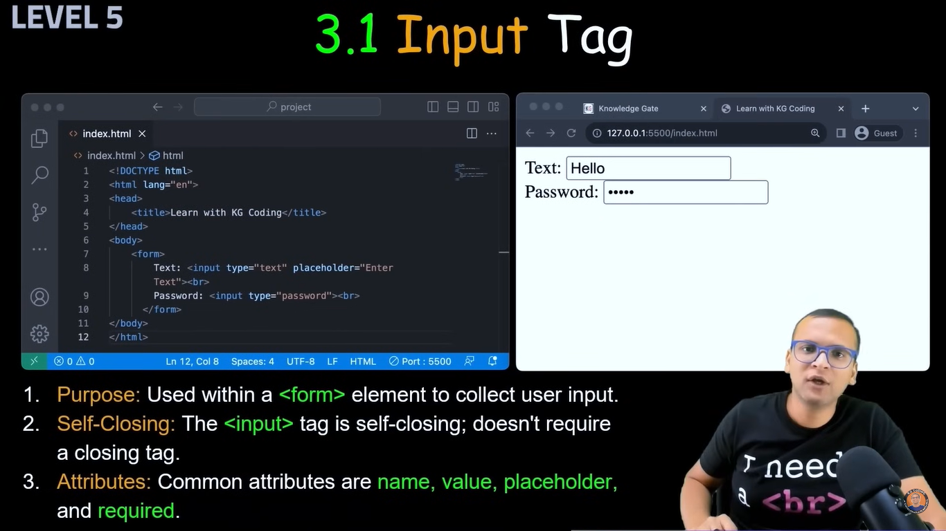

<!DOCTYPE html>

<html lang="en">

<head>

<meta charset="UTF-8">

<meta name="viewport" content="width=device-width, initial-scale=1.0">

<title>Form Tag</title>

</head>

<body>

<form>

Username: <input type="text" placeholder="Enter Username" required="True"> <br><br>

Password: <input type="password" placeholder="Enter Password">

</form>

</body>

</html>

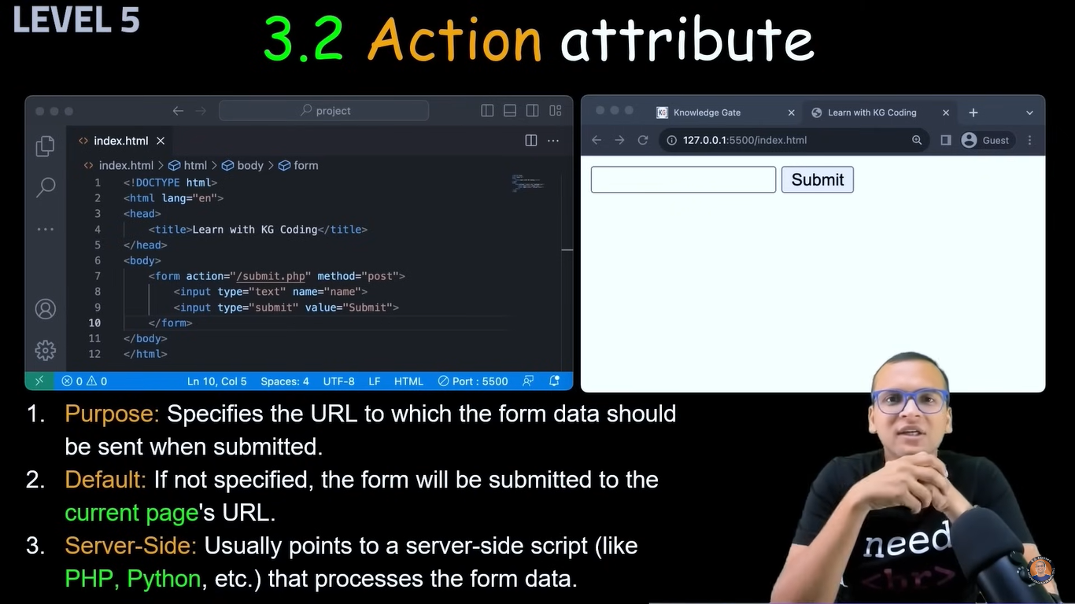

<!DOCTYPE html>

<html lang="en">

<head>

<meta charset="UTF-8">

<meta name="viewport" content="width=device-width, initial-scale=1.0">

<title>Form Tag</title>

</head>

<body>

<form action="/login-data">

Username: <input type="text" placeholder="Enter Username" required="True"> <br><br>

Password: <input type="password" placeholder="Enter Password"> <br>

<input type="submit">

</form>

</body>

</html>

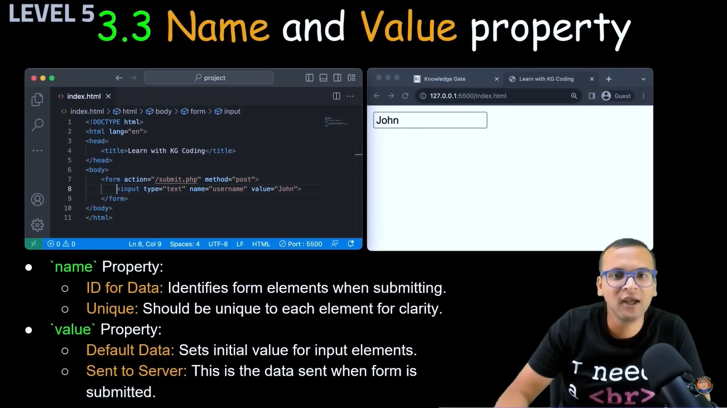

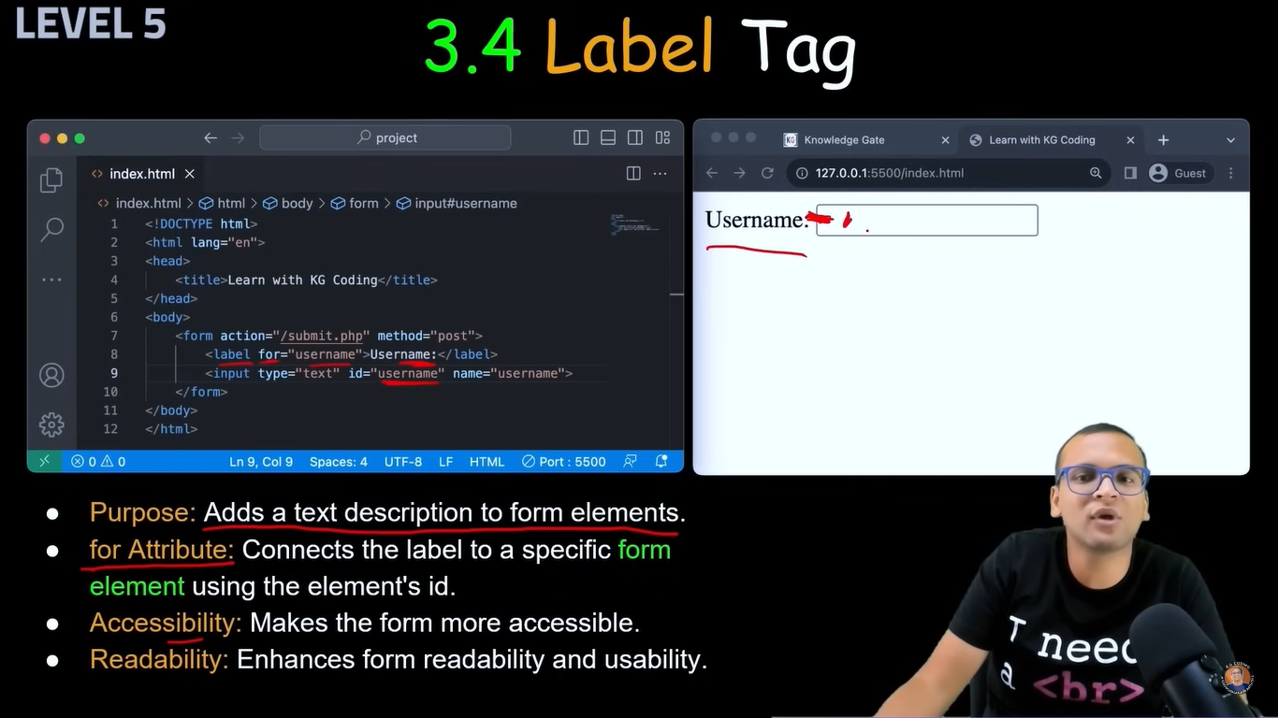

<!DOCTYPE html>

<html lang="en">

<head>

<meta charset="UTF-8">

<meta name="viewport" content="width=device-width, initial-scale=1.0">

<title>Form Tag</title>

</head>

<body>

<form action="/login-data">

<label for="user-id">Username: </label>

<input type="text" id="user-id" placeholder="Enter Username" required="True"> <br><br>

<label for="password">Password: </label>

<input type="password" id="password" placeholder="Enter Password"> <br>

<input type="submit">

</form>

</body>

</html>

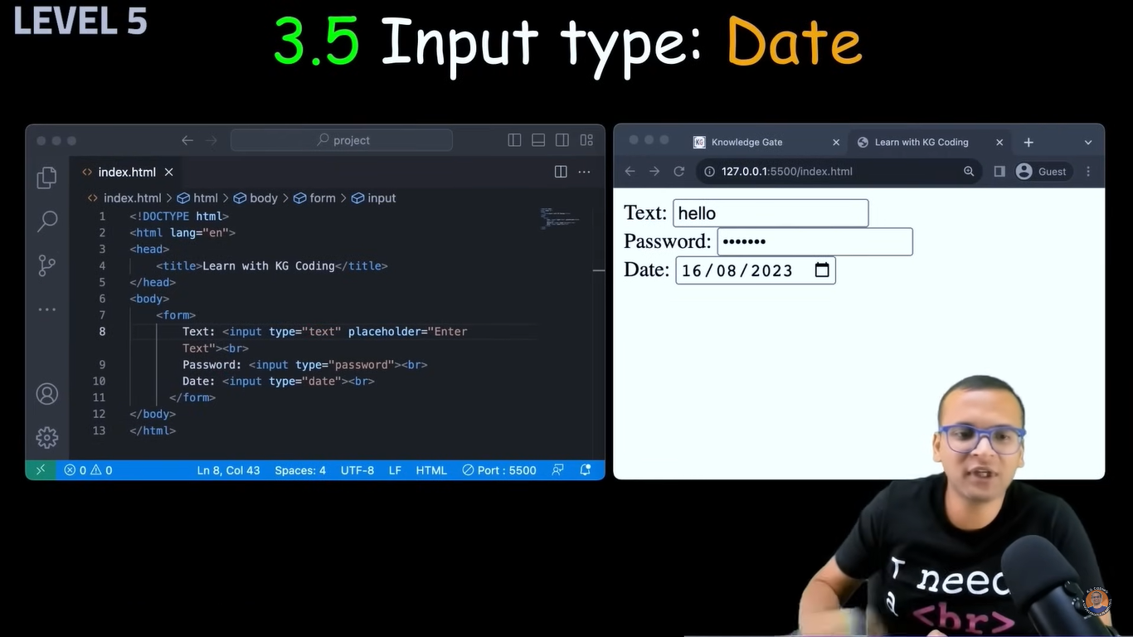

<!DOCTYPE html>

<html lang="en">

<head>

<meta charset="UTF-8">

<meta name="viewport" content="width=device-width, initial-scale=1.0">

<title>Form Tag</title>

</head>

<body>

<form action="/login-data">

<label for="user-id">Username: </label>

<input type="text" id="user-id" placeholder="Enter Username" required="True"> <br><br>

<label for="password">Password: </label>

<input type="password" id="password" placeholder="Enter Password" required="True"> <br><br>

<label for="date">Date:</label>

<input type="date"><br><br>

<input type="submit">

</form>

</body>

</html>

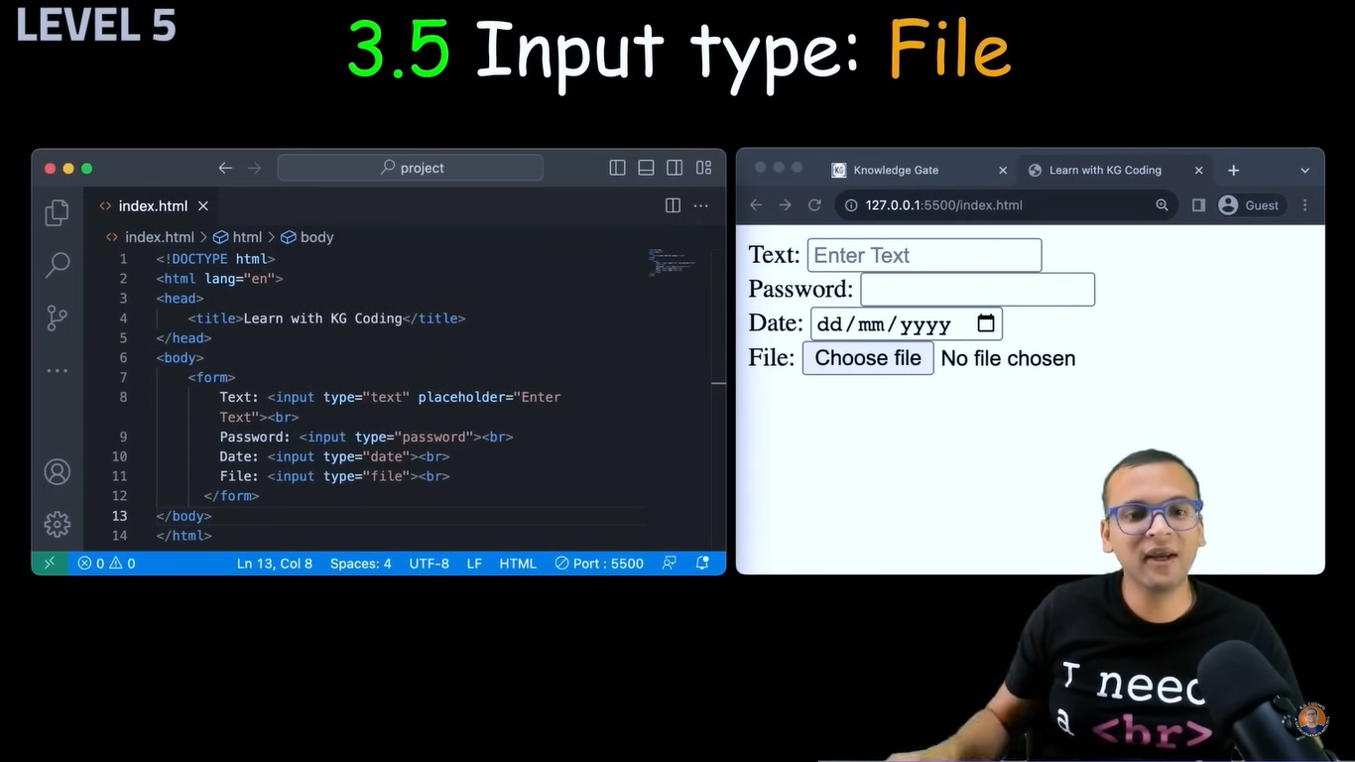

<!DOCTYPE html>

<html lang="en">

<head>

<meta charset="UTF-8">

<meta name="viewport" content="width=device-width, initial-scale=1.0">

<title>Form Tag</title>

</head>

<body>

<form>

Date:<input type="date"><br><br>

Upload File: <input type="file">

</form>

</body>

</html>

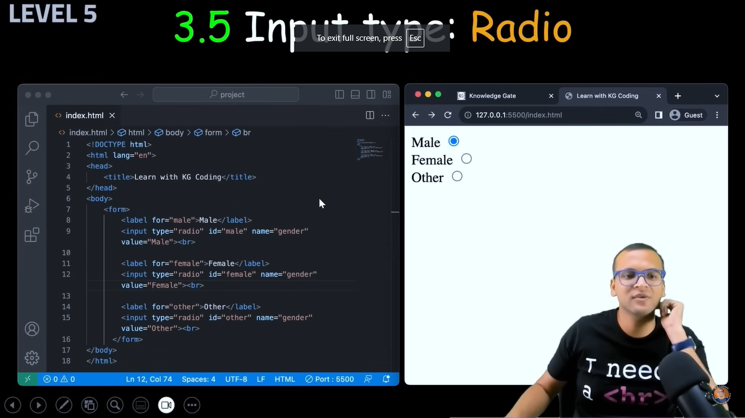

<!DOCTYPE html>

<html lang="en">

<head>

<meta charset="UTF-8">

<meta name="viewport" content="width=device-width, initial-scale=1.0">

<title>Forms</title>

</head>

<body>

<form>

<label for="male"> Male:</label>

<input type="radio" id="male" name="gender" value="Male">

<label for="female"> Female:</label>

<input type="radio" id="female" name="gender" value="Female">

<label for="other"> Other:</label>

<input type="radio" id="other" name="gender" value="Other">

</form>

</body>

</html>

For from label and id is used to connect radio button with “Male:” text, so even we click on male it get select, dont need to click on button always

Type is radio and name is gender so radio button will select any value where name is gender

“Value” is when we click on that button that value get stored

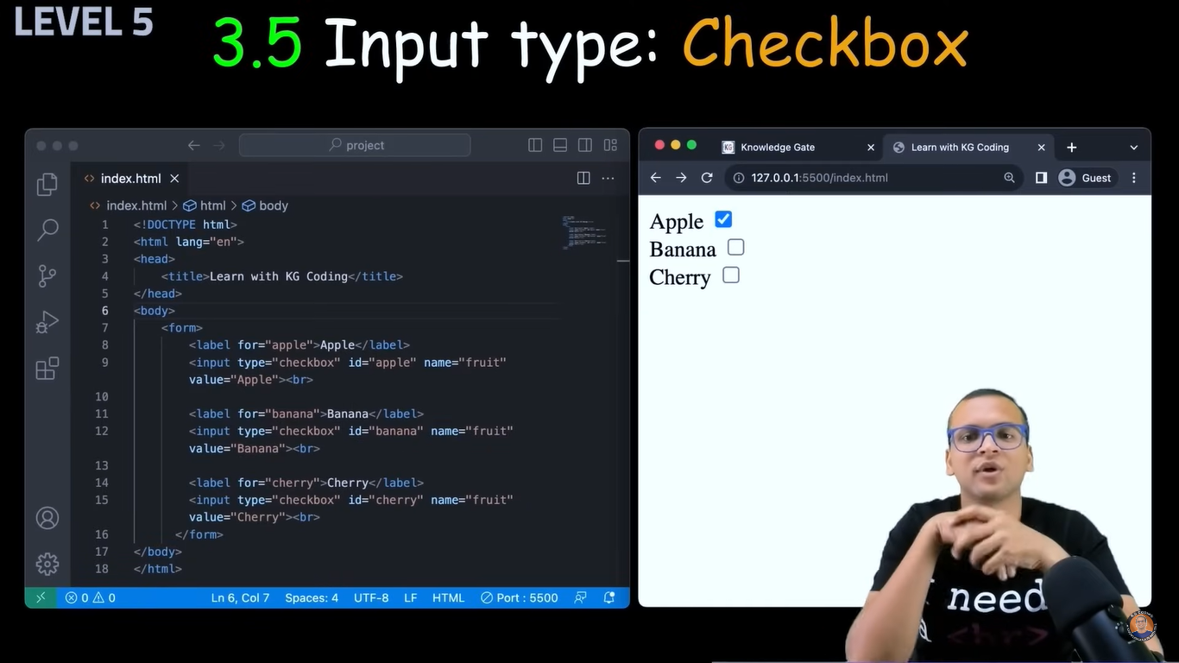

<!DOCTYPE html>

<html lang="en">

<head>

<meta charset="UTF-8">

<meta name="viewport" content="width=device-width, initial-scale=1.0">

<title>Checkbox</title>

</head>

<body>

<form>

<label for="ajinkya">Ajinkya</label>

<input type="checkbox" name="name" id="ajinkya" value="Ajinkya"><br>

<label for="chiku">Varesh</label>

<input type="checkbox" name="name" id="chiku" value="Varesh"><br>

<label for="viren">Viren</label>

<input type="checkbox" name="name" id="viren" value="Viren"><br>

<label for="ankush">Ankush</label>

<input type="checkbox" name="name" id="ankush" value="Ankush"><br>

<label for="bapu">Amit</label>

<input type="checkbox" name="name" id="bapu" value="Amit">

</form>

</body>

</html>

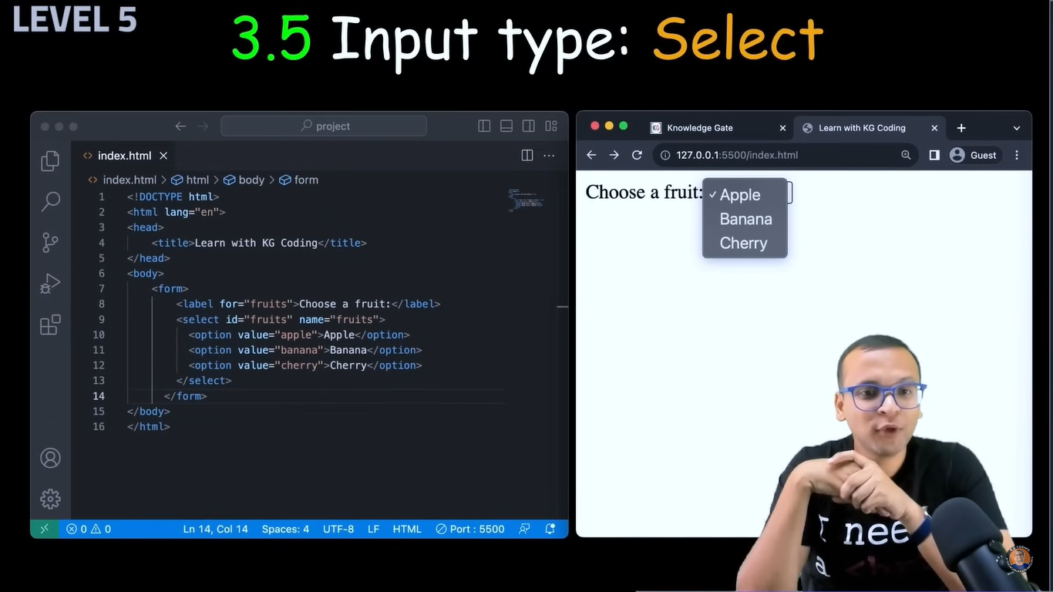

<!DOCTYPE html>

<html lang="en">

<head>

<meta charset="UTF-8">

<meta name="viewport" content="width=device-width, initial-scale=1.0">

<title>List</title>

</head>

<body>

<form>

<label for="name">Choose a Name</label>

<select id="name" name="Name">

<option value="ajinkya">Ajinkya</option>

<option value="chiku">Varesh</option>

<option value="amit">Amit</option>

<option value="viren">Viren</option>

<option value="ankush">Ankush</option>

</select>

</form>

</body>

</html>

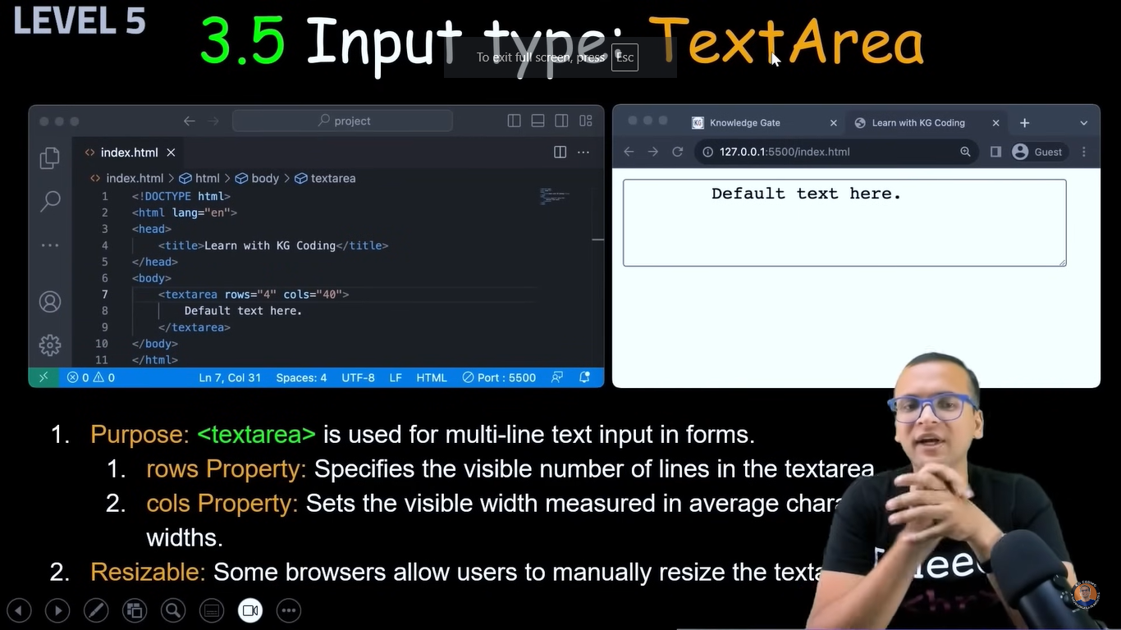

<!DOCTYPE html>

<html lang="en">

<head>

<meta charset="UTF-8">

<meta name="viewport" content="width=device-width, initial-scale=1.0">

<title>basic form</title>

</head>

<body>

<textarea name="eassy" id="eassy" cols="10" rows="6">

write eassy here...

</textarea>

</body>

</html>

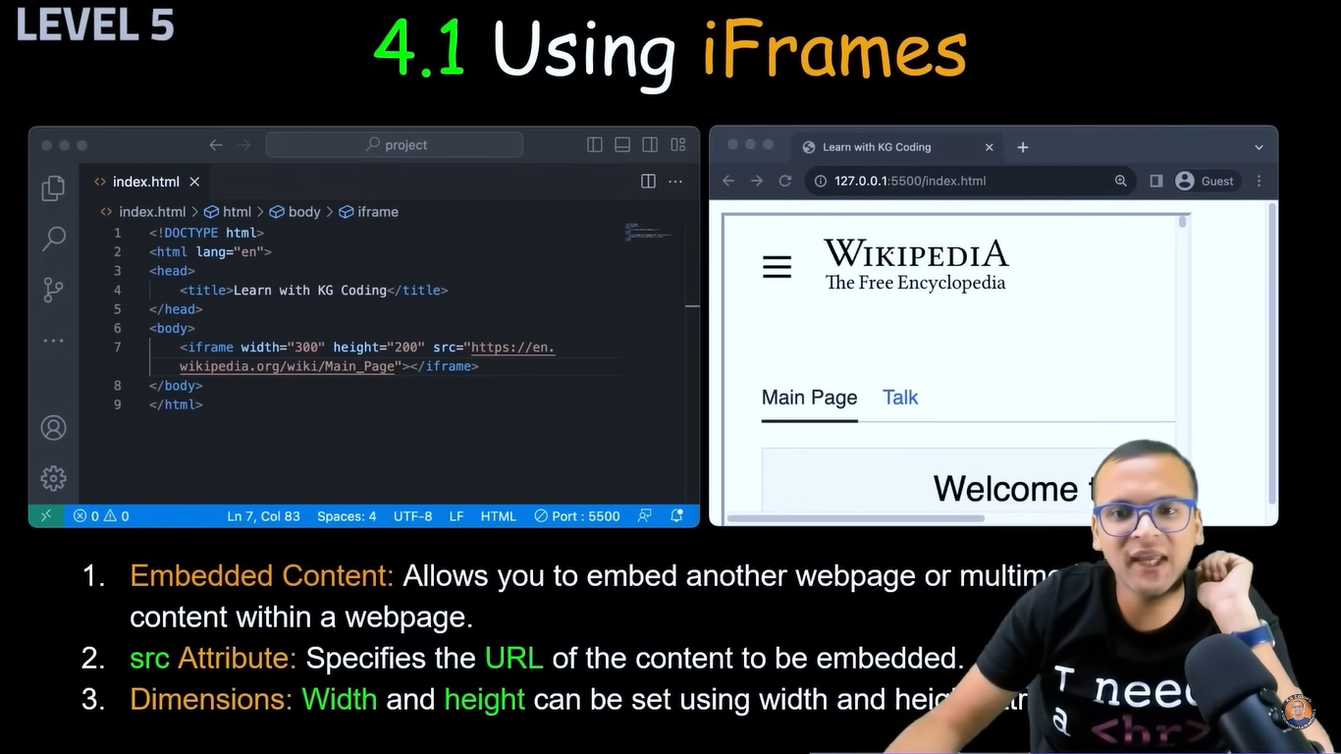

<!DOCTYPE html>

<html lang="en">

<head>

<meta charset="UTF-8">

<meta name="viewport" content="width=device-width, initial-scale=1.0">

<title>iFrame</title>

</head>

<body>

<iframe width="560" height="315" src="https://www.youtube.com/embed/o_5NdlY1Trw?si=QMdpWpK30lL2xVD9" title="YouTube video player" frameborder="0" allow="accelerometer; autoplay; clipboard-write; encrypted-media; gyroscope; picture-in-picture; web-share" referrerpolicy="strict-origin-when-cross-origin" allowfullscreen></iframe>

</body>

</html>



<!DOCTYPE html>

<html lang="en">

<head>

<meta charset="UTF-8">

<meta name="viewport" content="width=device-width, initial-scale=1.0">

<title>Project 5</title>

</head>

<body>

<form action="/candidate-data">

<ol type="a">

<li>Read all Instruction</li>

<li>Complete given tasks</li>

</ol>

<ul>

<li>Read all Instruction</li>

<li>Complete given tasks</li>

</ul><hr>

<table border="2">

<caption>Random table</caption>

<tr><th>Sr</th><th>Name</th><th>Surname</th><th>Age</th></tr>

<tr><td>1</td><td>Ajinkya</td><td>Patil</td><td>26</td></tr>

<tr><td>2</td><td>Varesh</td><td>Patil</td><td>16</td></tr>

</table><hr>

<h2>Contact</h2>

Name: <textarea name="Name" id="name" cols="30" rows="1" placeholder="Enter your Name" required ></textarea><br>

Email:<textarea name="Email" id="email" cols="30" rows="1" placeholder="Enter your Email" required ></textarea><br>

<label for="countrycode">Contact No:</label>

<select name="countrycode" id="countrycode">

<option value="india">+91</option>

<option value="pak">+92</option>

</select>

<textarea name="mobno" id="mobno" cols="30" rows="1" placeholder="Enter your Mobile No" required ></textarea><br>

<form>

Birth Date: <input type="date"><br>

Upload CV: <input type="file" required><br>

<input type="submit">

</form>

</form><hr>

<iframe width="560" height="315" src="https://www.youtube.com/embed/z0n1aQ3IxWI?si=Ain6NEtH2kS6mxl1" title="YouTube video player" frameborder="0" allow="accelerometer; autoplay; clipboard-write; encrypted-media; gyroscope; picture-in-picture; web-share" referrerpolicy="strict-origin-when-cross-origin" allowfullscreen></iframe>

</body>

</html>